4-101 AVN REGT

Volume 1, Issue 8 15 JUN 2006

FROM THE COMMANDER:

Dear Wings Families,

The temperatures are definitely rising and the mission OPTEMPO is not slowing down. Your Wings Soldiers continue to accomplish amazing tasks everyday and no amount of heat, sand or sweat keeps them from accomplishing their daily tasks. The battalion is well on the way to over 20,000 hours flown and will certainly break that unprecedented mark early in July. The Wings Battalion is also rapidly approaching over 2 million gallons of JP8 pumped. The maintainers continue to keep our ground and air fleet in top shape to support all missions given to us by Multi-National Corps – Iraq (MNC-I).
Our focus remains the mission at hand but is quickly turning towards redeployment, Fort Campbell, and most importantly reuniting with our loved ones back in the good ole US of A. We are at a very critical point in this deployment. Your Soldiers in Iraq must remain focused on the current task at hand and not get distracted by our upcoming redeployment. Our mission here is not over until the transfer of authority in September and

News

realistically speaking, not until we all step off the airplanes at Fort Campbell. Please encourage your Soldier to remain vigilant with the task at hand so that everyone remains safe.
We have had so much love and support from our friends back home. The Wings Battalion recently received unit t-shirts. The Kingsman, Blackwidow and Comanchero Associations generated enough money to send some 550 shirts to 4th Battalion. These beautiful shirts, designed and printed at cost by the Ken Young Company in Cairo, GA, were a wonderful surprise for your soldiers. This project involved hours of coordinating sponsorship from folks all across the states—with the goal to have every state represented. It also involved designing eight different shirts—a unique design for each company. We are very grateful for the support from our fellow Veterans.
We look forward to sharing “war” stories with you when we return.
As always our families are our biggest supporters. Thank you for continuing to support your Soldiers in Iraq, like you’ve done for many long months…the light is definitely visible at the end of the tunnel. My heartfelt thanks to all the hard working FRG volunteers and our Rear Detachment—I know I’ve thanked you before, but I could never thank you enough. You all definitely make our jobs here easier with your love and support. Thanks again for all you do everyday….we’re almost there!

W06
LTC Tony Fish
HAWK ASSAULT!
Dear Hawk Family,
While Steve is enjoying his much needed and well deserved R&R leave in the States, I get the opportunity (read the honor) of writing this month’s newsletter. To begin with, Hawk Assault Soldiers are short. Not Michael J. Fox vertically challenged short, but short in respect to the time we have left on LSA Anaconda. One can ask most of our Soldiers how much longer we have here and most can tell you to the day the number of nights we have remaining. Some, including Tommy Tuchscherer, can tell you how many mili-seconds until the redeployment. Don’t get me wrong, Balad, Iraq is one of the most sought after Forward Operating Bases in Iraq. Anaconda’s amenities rival any in theater and there are much worse places to deploy. However, it is universally understood and time proven that when in Oz (Or in our case IZ), there is no place like home. Many of your loved ones are currently talking about what kind of car they plan to buy, how much they want to spend on a house, and most importantly, how much they look forward to being reunited with their family and friends.
The sign when entering Iraq is now amended to the following: “Iraq, Home of the Sun.” Although it is written in Arabic, everyone gets the idea. The sun comes up early and the temperature is usually over 100 degrees by 10:00 AM. The hair dryer effect from the hot wind is in full force and we are all working effortlessly on the farmer’s tan our uniforms allow us. As many are well aware, we experienced a massive generator failure in the first week of June. Set aside the lack of lights, Internet, and AFN cable in the rooms, the daytime heat made the rooms unbearable in which to sleep. For the three days without power, many Soldiers slept in the offices or in “cool rooms” set up by the battalion and brigade. As a team we overcame this hurdle and we can once again watch reruns of Seinfeld and previously recorded sporting events in the luxury of our air conditioned pods.
You are all well aware of the impact your loved ones have on the mission out here. It is most inspiring that after eight months of intense work, now coupled with the sweltering heat, blowing dust, and rolling power outages, they still continue to put forth this remarkable effort to make 4th Battalion one of the most successful and sought after units in the Army. Although Hawk Assault Soldiers work hard, they certainly find an opportunity to play hard too. The Toby Keith Concert was an enormous HHC draw, and the pool on the East Side of Anaconda is being used as well as the Movie Theater and MWR facilities. A few of our Soldiers, specifically SGT Plotz, SGT Snedden, and SPC Shannon are taking the opportunity on this deployment to broaden their minds. Our very own 1LT Colin Chappell is currently teaching “Western Experience and European History” at the education center as part of the College Level Examination Program (CLEP) and the above mentioned individuals are his most loyal and studious pupils. There were a handful of promotions at the beginning of June. Congratulations goes out to SPC Brian Penn, SPC Tia Snow, and PFC Christopher Rhinehart for their much deserved promotions. These Soldiers are a great example of a Hawk Assault Soldier and we know they will continue to make their families proud in the future.
As always we are diligently working to meet our end goal of successful mission accomplishment. We are well aware of and heartily appreciate the sacrifice of our family and friends back home and vigilantly await our reunion. In light of tremendous public and media consternation for the war effort, it is heart warming to still see the dedication and commitment of our Hawk Assault extended family back home. We thank you for your continued love and support and we will see you soon.

CPT Jeff Stone “Hawk 5” Executive Officer

SFC Elgreco Shaw “Hawk 4N” S4 NCOIC and Acting 1SG”
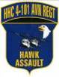
(All pictures provided by “Hawk 6” CPT John (Stephen) Albright…Thank You)

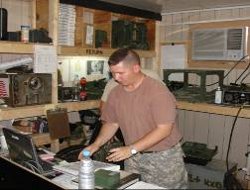

SPC Shepherd keeping the BN talking

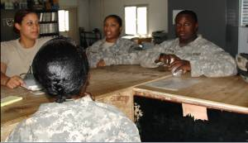
Supply keeping the battalion…well…supplied

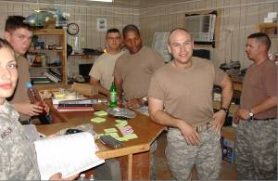
Commo team building before the work day

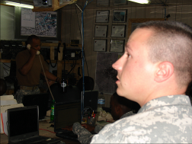
SGT Thomas coordinating operations in the TOC

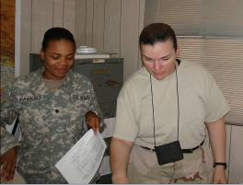
Flight Operations keeping track of the battalion’s flight hours.

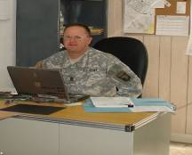

CSM Sowers working on the next battalion tasking.

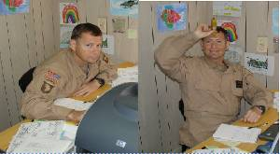

Greg Demoss looking busy / Greg Demoss looking normal

COMANCHEROS
I hope this letter finds you all well. I’d like to take this opportunity to introduce myself as the new Comanchero 06. As you probably already know, CPT Brian Ward and I changed command near the end of May. Brian was highly regarded as a commander, did an outstanding job with the company and has since moved on to take charge of the redeployment effort for the Battalion. I just finished 11 months of command as Hawk 06, the Headquarters Company Commander. I am married to my beautiful wife Shawna and have three kids, Malachi (6), Kieran (4) and Alauna (15 months).
Since taking command, I have been absolutely impressed by the professionalism, expertise and proactive work ethic of the individuals that make up this company. Their performance while maintaining an unrelenting OPTEMPO, surging to plan and execute Air Assaults in support of 1-32 CAV and support our sister companies when they are conducting Air Assaults, and their consistent execution of day to day activities that keep the company running is nothing short of extraordinary.
Additionally, I am extremely grateful to the FRG Leaders that have stepped up in recent weeks to take charge of the group and lead with enthusiasm. A huge thanks to Gretchen Cahill and Jennifer Wick (Co-leaders), Becky Hollandsworth (Treasurer and Key Caller), Becky Farwell, Justyne Strom and Stephanie Day (Key Callers), Beth DeCrisci (Community Events) and Michelle O’Neill (POC for out of town spouses and family) for picking up and continuing the great work that the A Co FRG has been doing since before the company deployed back in October. Thanks also for kicking tail in your rivalry with Chuck Co (Charlie Company) – you make us proud!

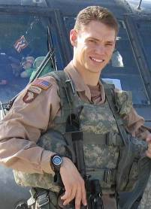
Comanchero 06 – CPT John Wilson

June has seen the temperatures rise to unimaginable highs. Doc Savel (our flight surgeon) reported 147*F on a black bulb thermometer.

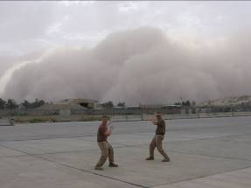SPC Crockett and Bryant cringe in fear as a dust storm approaches, near Baghdad International Airport.

Despite the heat, the company has accomplished every mission assigned and continues to set the example in the battalion.
To take a break from the long hours, the guys enjoyed a concert by Toby Keith, with an opening act by Spike Nicer (CW2 Josh Havill dreams!).

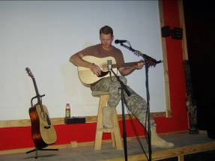
Spike Nicer (aka CW2 Josh Havill) plays a concert for his thousands of screaming fans.

Back at the CP many of the guys work on their control touch flying recently purchased remote controlled helicopters. SPC Busch has become quite proficient; able to land his on LT Bunt’s outstretched hand. Don’t ask them to fly in formation though… Beyond that, it’s been another month of hot days and long hours.

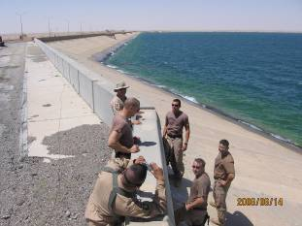
One mission took the guys to the Haditha Dam. It was a nice change of scenery.

In other news, PFC Kevin Wingard and his wife Melissa had their second child, a boy. 1LT Joe Rozycki obtained Pilot in Command status - we immediately posted a Notice to Airmen (NOTAM) across the Iraq Theater of Operations. SSG Jeff Day turned the big 3-0. We enjoyed his lists of “Top 30’s” - they were definitely entertaining. SPC James Gray reenlisted for six years to go to school upon redeployment to become a 21P, Prime Power Production Specialist – the military equivalent of a civilian Electrical Testing Technician.

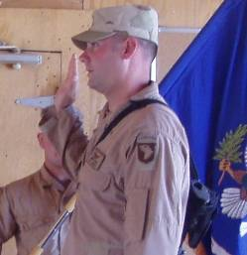
SPC James Gray – reenlisting.

1LT Dave Bunt was promoted to CPT and SPC Chuck Berry made us proud when, after his promotion to SGT, he recited the NCO Creed by memory, next to two other badly faltering newly pinned SGTs from elsewhere in the battalion. The company broke into a roar of whooping and hollering, “SHOOT ‘EM IN THE FACE!”

The Comancheros continue to work at a record pace to ensure the safe movement of Soldiers around the battlefield. The end is in site, it’ll be nice to get back and enjoy the cool weather and holidays. Thank you for your continued sacrifice as we push through the hottest months. It’s not easy taking care of all the things you do on your own, but know that we appreciate you immensely and rest assured, we will be home very soon. My number one goal over the next three months is to ensure that every Comanchero makes it home to their loved ones in one piece, safe and sound. We are starting to see the light at the end of the tunnel and the realization that we truly are on the down slope is bringing excitement to the guys.

Sincerely,

CPT John C. Wilson
1SG Migelangelo Salinas
“Shoot ‘em in the Face”
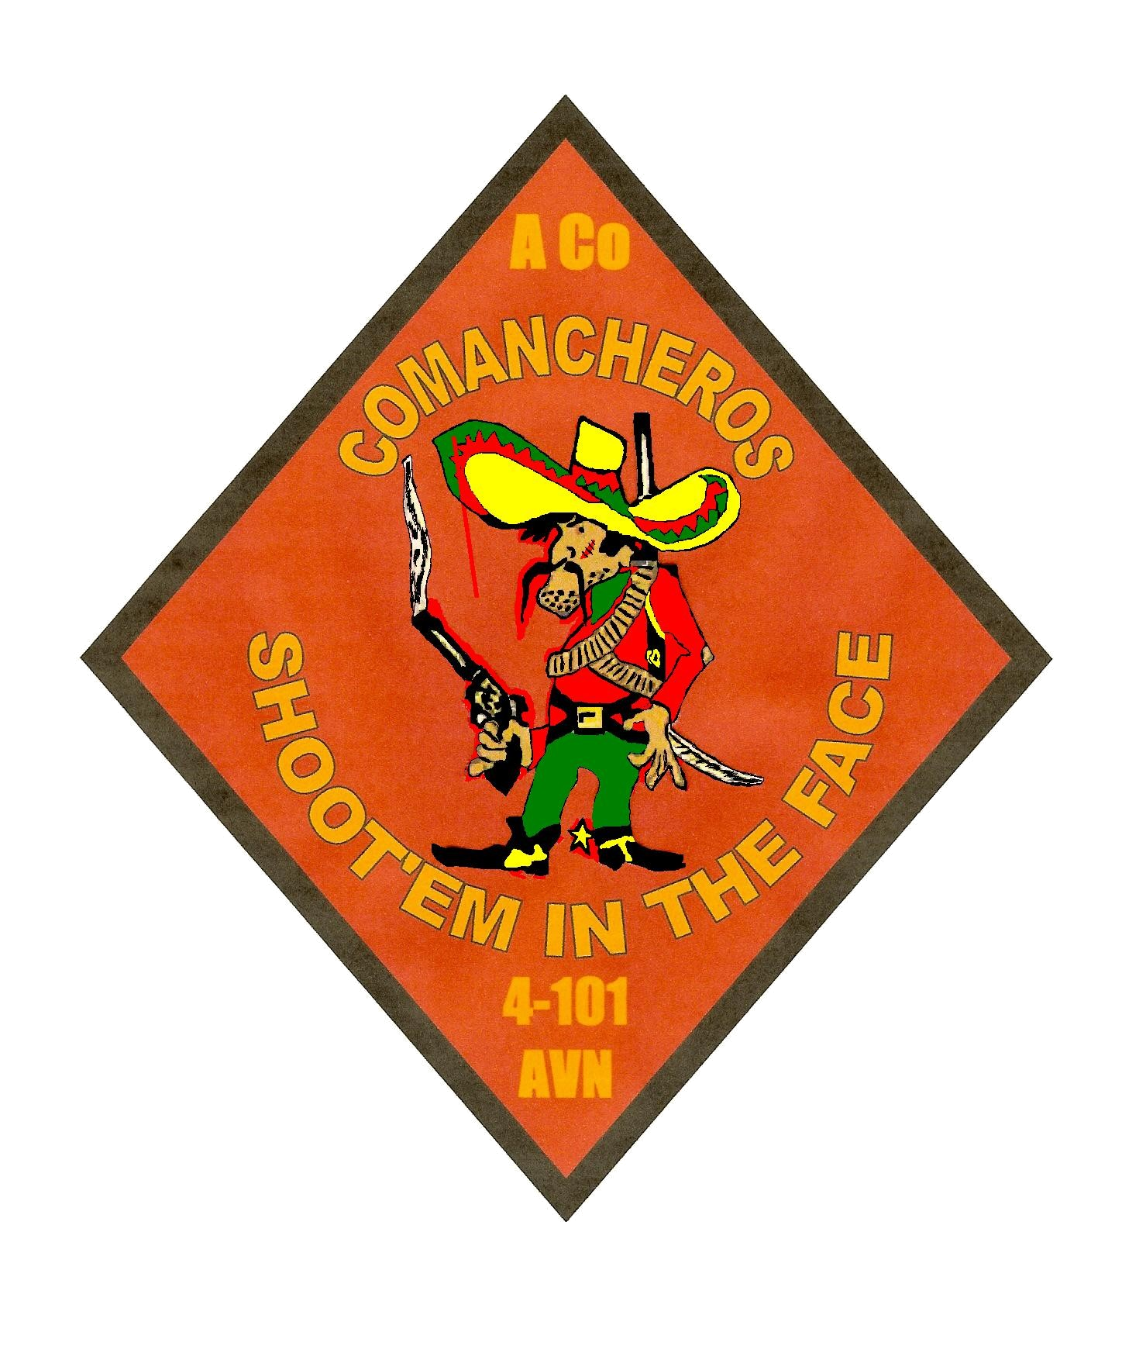

Dear Friends and Family of the Kingsmen,
The months are literally “Flying By” now. The light at the end of the tunnel is starting to flicker for everyone in the company now as the closing months of the deployment are fast approaching. The sun is high in the sky and burning hotter than ever but your thoughts and prayers keep our heavy hearts in the shade. Every step we take brings us closer to our loved ones. We saw a few days without power in our housing area and the lack of air conditioning in our rooms lent to a harassed, nerve-frazzled quality to our daily routine, but as always the Kingsmen buckled down and got the mission done.
Our pilots, crew chiefs, and door gunners continue to carry us through the hot summer with determination and an astonishing commitment to finishing the mission that we’ve started and have done with excellence for the last eight months. The officers and NCOs have an amazing commitment to their Soldiers and each other and have only one goal in mind: bring their Soldiers home to their families, safe and sound. As long as we stay committed to that goal, everything else will take care of itself.
We continue to conduct general support missions in support of Multi National Corps – Iraq on a daily basis. Most pilots are nearing the 400 and 500 hour mark, while our crew chiefs and door gunners are already closing in on individual marks of 600 combat hours during this deployment. What a remarkable accomplishment by all of these crewmembers! By the end of our year tour in Iraq, the company will have flown nearly 8,000 combat hours, moved over 25,000 passengers in support of nearly 900 different combat air movements. The family and friends of these amazing men and women have every right to be proud.
The Kingsmen have also been called upon to execute many more air assaults in support of the 101st Airborne Division (Air Assault), as well as Special Forces units within our Area of Operations. The adaptive and “no fail” attitudes of our pilots and crewmembers has led to the capture of numerous insurgents and countless pounds of weapons and explosives. To date, this company has been asked to execute more air assaults than any other in the battalion and each one has been carried out with professionalism and a style all our own.
The Kingsmen would like to welcome our newest crew chief PFC Phillip Swearingen to a challenging and rewarding assignment with Bravo Company. He comes to us following service with the 160th Special Operations Aviation Regiment. He is 21 years old, married to Dawn Swearingen and hails from Davenport, FL.
We recently held another BBQ to welcome new soldiers and just take a break from the daily grind. In addition, it was to mark my one year anniversary as the commander of this elite company; there is no place I would have rather served for the past year, it has truly been my honor! The BBQs and gatherings are always fun but would be so much better when we can share those good times and relax with all of you at home.
The unit’s redeployment is approaching soon and now more than ever it is important to keep the FRG Leader, Tanya Hatley, and the Rear Detachment updated with your most current phone and address information so that you can be reached when important information about our return is released. As of right now, it is fairly certain that your Soldier will be returning before October 15th. I promise that when I know something about our timeline for our return, you will be updated with the facts. Right now our exact dates are a little blurry, but we should know more soon. It will be very hard to predict an exact day for return so if you are planning a stay at Fort Campbell, KY to attend our return, I would plan on arriving a few days early and plan on possibly staying a few days later, as well. So much of our return is out of our control, but we will do our best to keep you informed. In closing, I’d like to say thank you to the Soldiers and Families that have made my last year of command so rewarding. It has truly been an honor and privilege to work alongside great men and women like you. As always, we are thinking of you and miss you very much. Keep us in your thoughts and prayers; honor us by living in peace, and we will continue to serve with pride and distinction.
Sincerely, CPT Mike “Jethro” Stull
Kingsmen 6

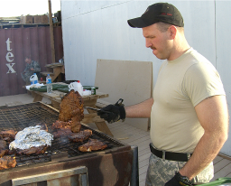

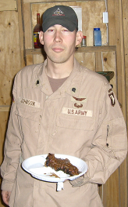
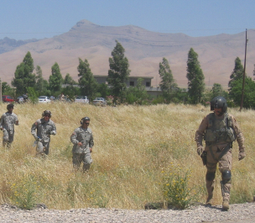

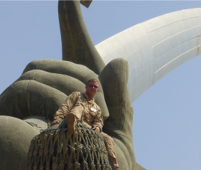

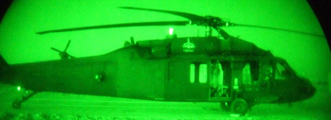
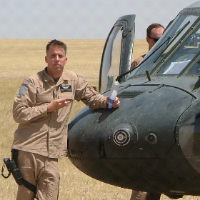

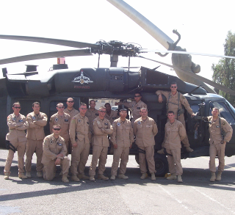

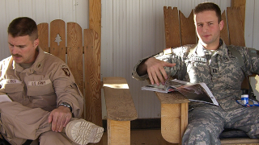

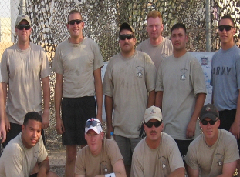

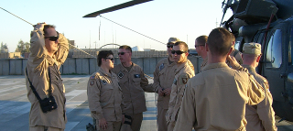

Blackwidows

Another month has passed and just a few more to go. The Blackwidows are on the down slope of this deployment now. However that hasn’t stopped our mission focus or the vigilance of the Blackwidow Soldiers.
This month, just like the last one, we had numerous exciting events happen. SPC Miller received his promotion to Sergeant. He was pinned by SFC Brown. After the pinning it was stressed upon him, the increased responsibilities an NCO carries.

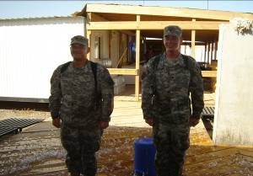
SGT Miller and SPC Williams after their promotion.

In addition to SGT Miller’s promotion we promoted PFC Williams to Specialist. SPC Williams is an attached door gunner from the battalion’s FSC. They were both rewarded with several coolers of ice water to help cool them off. Additionally, SPC Galyon was awarded the Good Conduct medal, that he earned by serving three years of meritorious service.

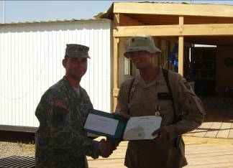
SPC Galyon receiving his Good Conduct Medal.

1LT Shane Radtke and CW2 Warren Brown are two of Charlie Company’s newest Pilot-In-Commands. Both of them have already flown several missions and we continue to expect great things from them in their new positions.
CW2 Murphy and CW2 Higgins are our newest Unit Trainers. CW2 Murphy now assists the Instructor Pilots with training and refreshing Charlie Company pilots with their Instrument Flying. CW2 Higgins assists in NVG Progressions and Refresher Training.
Specialist Turner had the opportunity to go on a Duty Day with God. The Duty Day with God is where Soldiers get the chance to go to the International Zone and see sights such as the Iran-Iraq Unknown Soldier Memorial and go to the embassy pool.

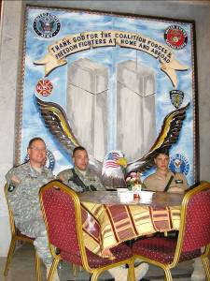
Here is SPC Turner taking a break at the embassy during the Duty Day with God.

On behalf of the Charlie Company fathers, we would like to thank the Blackwidow spouses and families for making this the best father’s day possible given the circumstances.

CPT Brian G. Wood, CDR
SFC Scott Brown, 1SG


Charlie Co
4-101
AVN

DESPERADOS
May has come and gone, and June is here, but summer is not yet in full swing. Delta Company continues to support the Battalion’s incredible mission pace, and her soldiers are working hard every day to ensure that the birds keep flying.
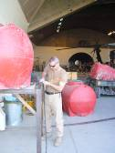
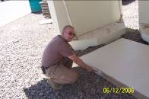
The heat has been intense, topping 122 degrees Fahrenheit in some places. This means that keeping cool is a big priority, and to this end SFC Mihalko and 1LT Granlund worked to make the large cooling units for the hangar operational. They succeeded, and now the big air conditioners are keeping Soldiers cool despite the sun outside. Other construction projects went on as well, such as the monstrous roof which was erected over the portable toilets out at the HAS. SGT Bridgeman oversaw the construction of the roof, and SPC Beul, SGT Tanudjaja and SSG Davis helped to put the entire structure together. While there is now shade, the smell seems to be trapped.
Careers for many are on the rise as well, since promotions came with the last several weeks. PFC Hatt and Darbyshire was promoted to Specialist. Joining the ranks of the NCOs, Bowe and Smith made the E-5 list. Congratulations to these Soldiers on their promotions, and we expect a lot of our new NCOs. Both SPC Bowe and Smith promotion ceremony will take place after they return from their much needed R & R
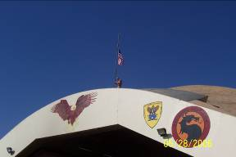
Much to the relief of SFC Mihalko, 1SG Paul returned from leave. This relief was short lived, however, since 1SG Paul immediately put SFC Mihalko to work on various hard labor projects. 1LT Wolcott, the company XO, took command of the company when CPT Hathaway went on leave, and he hasn’t been seen since. 1LT Mayo joined the night shift, again, and no one is quite sure what he does. 1LT Granlund attempted to host a memorial day BBQ, but was snubbed by the platoon and ended up with a great deal of steak to consume on his own. SFC Mihalko flew a flag at half mast in memory of Soldiers who have given the ultimate sacrifice.
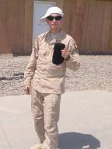
Getting ready for the replacement unit, Top has decided that all the gravel around the HAS needs to be smooth. His various plans for

constructing the Delta Company Empire have been delayed, however, since construction has not yet begun on permanent buildings to replace the trailers that the headquarters shops now occupy. CW2 Sanchez has apparently reached the breaking point. Seen here, looking somewhat like a 12 year old thug, he poses for his “have you seen me?” milk carton picture.
CPT Hathaway, CDR
1SG Paul, 1SG

Forward Support Company

Commander’s Corner
Dear FSC “Workhorse” families,
Another whirlwind month has passed us by. Eight months and counting….It’s hard to believe we only have 4 months left!!! If the last four months go by as fast as the first four, we will all be home before you know it. The month of June has seen the Workhorse Soldiers continuing their excellent work keeping this battalion flying. From pumping fuel, fixing vehicles, distributing supplies, to checking ID cards at the DFAC, your loved ones are playing a big part in this battalion’s overall success. However, as with every month we also took some time to enjoy ourselves. For this month’s morale day we decided to have a basketball tournament. And again, the POL platoon is the proud owner of the commander’s cup. For our next morale day, we have decided to just have a pool party. All the other platoons have to regroup and come up with a new plan to challenge the POL platoon’s dominance in the monthly competition. We will see, only four more months to go!
The weather has definitely taken a turn for the worse over the past couple of weeks. The mercury is routinely hitting 115 degrees over here right now, and it will be getting even hotter. Air conditioning is everyone’s favorite appliance right now. And we definitely feel it when we have power outages. When you talk to your loved ones on the phone, make sure you remind them to drink water.
As always, I have plenty of good news to pass on this month as well. First off, I would like to congratulate SSG Meyers, SPC Hamilton, and SPC Paulk on their promotions. They are all deserving individuals. Congratulations also go out to SSG Farmer and SPC Hamilton (big month for him) for their reenlistments. The Army is truly lucky to have both of these individuals. And finally, I would like to extend a warm welcome to PFC Andrika Jackson (DFAC) and PV2 Benjamin Carney (motorpool) who are the two newest Workhorse members. Welcome to the company and good luck in the future.

First Sergeant’s Corner

Its great be back after my two weeks of R&R, the time went by fast but I enjoyed every minute of it. After that, I am now charged up to get the unit ready for redeployment. I would like to congratulate all the Workhorse soldiers that were promoted this month, well deserved to all. I would also like to welcome all the new Workhorse soldiers that arrived in Iraq, I look forward to serving with you all. We are definitely in triple digits here now, so keep an eye out for your soldiers and ensure they are drinking water. Again, I would like to thank all the Workhorse families and friends for all the support you show for your soldiers!

Congratulations to SGT Myers (DFAC) on his promotion to SSG, a very deserving promotion. Congratulations also to PFC Hamilton (Distro) and PFC Paulk (Distro) on their promotions to SPC. We are all proud of the hard work put forth by alL three of these Soldiers!

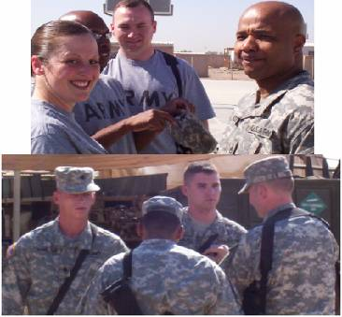

Re-enlistments

After careful consideration, SSG Farmer (HQ-left) decided to reenlist indefinitely. Congratulations and thank you. He thanks his wife, Jerri, and their kids for all the support!

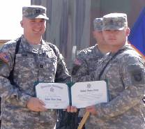
Congratulations to SPC Hamilton (Distro – right) on reenlisting for 6 years. Good luck to you in your future in the Army. We are looking forward to hearing great things about you and Kasandra for years to come.
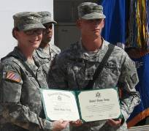

Soldiers’ Corner
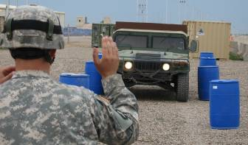
Distro gets in a little training along with competition in the Battalion’s truck rodeo. Does this remind anyone of driver’s training in high school?
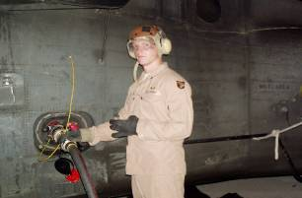
SPC Baydek is having the time of his life pumping JP8 into this aircraft. For POL it seems like work is never done.
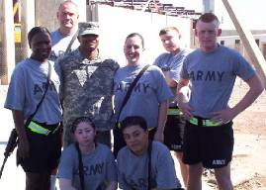
DFAC took a short break from their long hours in order to celebrate SSG Myers’ promotion.
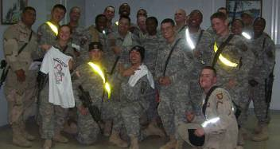
We are not exactly sure what they were so happy about, but the soldiers of motor pool got together and pose for their families.

Welcome to the Workhorse Family! We would like to take a moment to welcome PFC Jackson and PV2 Carney to the company. PFC Jackson is coming to us from Dallas, Texas and is proud to be working in the DFAC. PV2 Carney is joining the Motor Pool and hails from Ohio. We are happy to have them join us on our trip to the desert!

 CPT Ison, CDR

1SG Moore, 1SG

RENEGADES

June is upon us and as of June 7, we have been in Iraq for a total of six months. As you have probably heard, the weather here has definitely turned HOT. The average temperature has been about 115 degrees Fahrenheit, add to that everything that our aircrews wear on a mission and you realize very quickly how important it is to stay rested and drink plenty of water.
The guys are doing an incredible job here, whether it be flying a mission that lasts all day in the scorching heat, or staying up and working on the aircraft all night, they are always hard at work. As you might imagine, we are all anxious to return home as quickly as possible and as we get closer to that time, I will certainly pass along information as to when you can expect us back in the USA. Once we return, we will still have about a one week stay at Ft. Dix to go through the demobilization process before returning to Kentucky and our families.
I would like to welcome SSG Bill Stocker who has recently joined us full time over here. Bill is from Lawrenceburg, KY and came over last month as a replacement for a soldier who was injured several months ago. He is a welcome addition and has been doing a great job since his arrival. Plus, being a member of the Kentucky Army National Guard and working at the flight facility was a great benefit to us, but probably not him since that is what got him sent over here.
Please keep the support for your special soldier in the unit as word from home really is a motivator for everyone here. Your letters, emails, packages and phone conversations mean more than you might think to the guys and I appreciate everyone’s efforts. Again, thanks for another month of support and if there is anything I or the company can do for any of you, please let us know.
Congratulations to several of our soldiers for reenlisting and receiving their tax free bonuses as well as those soldiers who were just promoted.
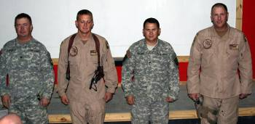
SGT Parker, SGT Stevens, SGT Hagan, SSG Grigsby
Congratulations to the above soldiers who recently re-enlisted into the Kentucky Army National Guard.

Also congratulations to the other soldiers listed who were promoted during Safety Day:
SGT Jimmie Parker
SGT Jay Stevens
SGT Tom Simpson

CPT Mark Brozak
Renegade 06

Meet the Company
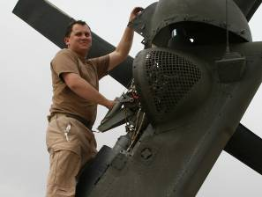
SGT Michael Hagan
Crew Chief
Wife: None in the foreseeable future.
Children: None in the foreseeable future.
Home: Crittenden, KY
Age: 26
Occupation: None in the foreseeable future, unless there is another deployment on the horizon.
Company: Good question.
Years in the Military: 8
What he misses most (besides his family): His expensive hobbies; fast cars, four wheeling, his dogs and paintball.

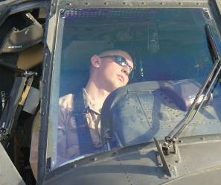
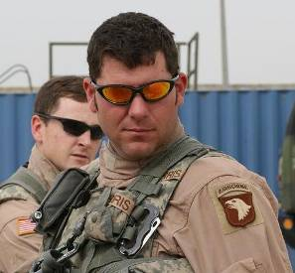
SGT Chris Morris
Crew Chief
Wife: Angie
Children: Conner (born this past December)
Home: Clarksville, TN
Age: 28
Occupation: Civilian Contractor
Company: DynCorp
Years in the Military: 9
What he misses most (besides his family): Going for a Sunday morning motorcycle ride and cooking.

WO1 Chad Russell
Pilot
Wife: Still holding tryouts
Children: Who wants to know??
Home: Elizabethtown, KY
Age: 25
Occupation: BUM, likes to fly when he can.
Company: Whoever will pay.
Years in the Military: 5
What he misses most (besides his family: Playing Frisbee with his dog (We think that is code for something else, but it is safe for the families to read).

CW3 Matt Willey
Pilot/Safety Officer
Wife: Maria
Children: None
Home: Versailles, KY
Age: 32
Occupation: Aviation Safety Officer
Company: Army Aviation Support Facility
Years in the Military: 11
What he misses most (besides his family): being at the lake.

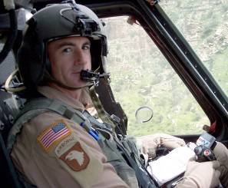
CW3 Barry Pylant
Pilot
Wife: Maureen
Children: Nicole
Home: Sherwood, Arkansas
Age: 41
Occupation: Helicopter Pilot
Company: Air Evac Liftam
Years in the Military: 24 (the same number as Jeff Gordon)
What he misses most (besides his family: Beer, cuddling and fishing (and not in that order).
A transplant from the Arkansas Army National Guard, Barry came over to our unit last summer to round out the pilots for the unit and he has been a great asset.
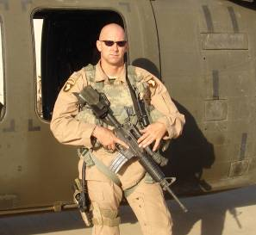

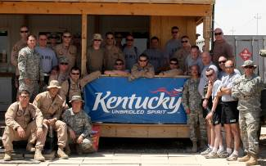
The company outside our CP during safety day.
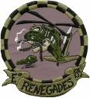
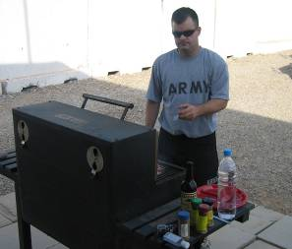
SGT Daryl Casey cooking steaks for us during safety day.


Here is a picture outside of our CP during a recent dust storm that blew in from the west. When dust like this is blowing it affects visibility so badly that we do not fly.

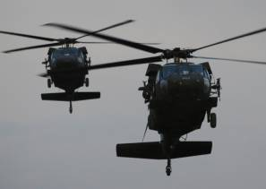
Two of our aircraft on an approach into Griffin Pad, Baghdad, Iraq.
PATHFINDERS
Pathfinder families and friends,

We have redeployed our first four Soldiers! I know this is exciting for all becuase it means the end is in sight for all of us. We won't be sending anyone else home until August now, but that is next month! Your Soldiers continue to do an outstanding job over here and I am very thankful for all of your support from back home. Please see the company newsletter for all the details of this past month's events. We have continued to present awards to deserving Soldiers, continue our mission to protect the General Officers, and have continued to train. The men have impressed me every month, and this past month hasn't changed that. I am proud to be a part of this unit and proud to have dedicated supporters like you carrying us through.

CPT Mike Wiser

WINGS of The EAGLE

POC is
CPT ADLER at erica.adler@ us.army.mil

