4-101st AVN REGT

Volume 1, Issue 3 16 JAN 2006

Inside This Issue
Commander Comments
Company Newsletters



News

FROM THE COMMANDER:
Wings of the Eagle Families,

It’s hard to believe it’s already 2006…having said that I hope that Santa was good to all of you and you had a great New Year’s Day. Fortunately, we were able to celebrate Christmas in Iraq. Most all of the companies had their own Christmas celebrations with Secret Santas and skits. The CSM and I were able to get around to most of the parties and hand out a little cheer. Even during the festivities many Wings crews continued to fly all over Iraq on Christmas and New Year’s Day transporting Soldiers safely around the battlefield.

It was quite an eventful month with a visit from Jesse James of Monster Garage fame and other notables. The Wings Battalion had the privilege of assisting in the transport of the Vice President of the United States as well as the primary missions of moving the Secretary of Defense, The Chairman of the Joint Chiefs of Staff and most recently, the Commanding General, US Central Command. The battalion continues to lead the way in maintenance, hours flown and most importantly passengers transported safely. The skies over Iraq remain dangerous; however, our biggest threats include wires, balloons, kites and birds. As a side note, we now have several “bird aces” in our midst.

Seriously, thanks to all for the phenomenal support over what is typically a difficult time to be separated from loved ones. The outpouring of support from the home front kept us all in touch with the meaning of the season and I know it means a lot to the Soldiers here. Your Soldiers continue to perform marvelously at an unrelenting pace. The mission sets continue to come and the folks here don’t miss a beat.

The R&R program has also kicked off; in fact, we have Soldiers that were able to celebrate Christmas with loved ones. I would remind everyone that as the Soldiers head home for some well deserved R&R that they don’t have to do everything the first 24 hours, maybe the first 48. I and the rest of the Wings Soldiers appreciate all you do everyday. Happy New Year.

W06
LTC Tony Fish

HAWK ASSAULT!
Dear Hawk Assault Family,
Happy New Year from Monsoon, Iraq. It seems just last year we were saying “Until Then” to our families and embarking on our year long endeavor to support the Wings of the Eagle Battalion in Iraq. Now that the holidays are over, it is back to our daily routine of facilitating our sister companies in bringing the fight to the enemy.
The rainy season is upon us here in LSA Anaconda. A single day’s rain impedes movement like you wouldn’t believe. Some Soldiers gawked at the vast amount of wood used to build the boardwalk around the battalion area when we arrived two months ago. Some questioned the necessity of covering every traveled, non- asphalt surface with truckloads of gravel. We even complained about the six inch deep gravel, calling it desert snow and longing for snowshoes. The response from the seasoned veterans in the outgoing unit was a resounding, “You’ll see.” Well, we now see! When it rains, and it does often now, the landscape becomes a vast expanse of puddles and mud. This is the kind of mud that cakes on the bottom of our boots. It is the kind of mud that brings SPC Romon Cortez from five foot nothing to six feet flat in a matter of four steps. Although the rain is a little of an annoyance at times and the mud is, well… mud, the company’s spirit, even during a downpour, is high.

The company Christmas party was an enormous success, thanks in large part to the efforts of you all back home. Special thanks to those who helped make the holiday video, ornaments, and decorations. I think we finally saw a solitary tear stream from 1SG Stephen’s face (he swears there was something in his eye) as he watched his daughter walk, unaided for the first time, across the floor back home. Due to the tremendous number of packages that you all sent prior to the holidays, the party was filled with more candy and cookies than we could fathom. Naturally, for the next few days the gym was filled with HHC soldiers repenting for their indulgence. Our utmost gratitude and our hearts go out to the Wolfe family, whose son Jeremy, a fallen brother in arms, made the ultimate sacrifice during 4th Battalion’s last deployment to Iraq. Their selfless gift of embroidered watch caps bought through the Jeremy Wolfe fund serves as a constant reminder of his presence in our unit, and the impact our unit made on Jeremy’s family. I am certain that the Wolfe family wants nothing more than for our Soldiers to serve as he served and to safely reunite with you all at the end of the deployment.
Our congratulations go out to SSG Kenny Robertson and SSG Andrew Defibaugh on their promotions. Just prior to the promotion ceremony we had to wrestle the Christmas ornaments from SSG Robertson (affectionately known as “Rob on the Fob”) as he planned to use them for target practice. He settled for promotion instead. Andrew Defibaugh comes to us from 563rd Maintenance Battalion. An intelligence analyst, SSG Defibaugh will no doubt be a valuable asset to the battalion.
The Hawk family bids a fond farewell to MSG Mario Meza, SSG Richard Frizzell, and PFC Julie Maguire. MSG Meza, who worked tirelessly in the S6 shop until recently accepting a position at the Brigade level will be missed. SSG Frizzell has begun a new endeavor in life as he is currently in transition to Fort Rucker with his family to begin Warrant Officer Candidate School; SSG Defibaugh has some big shoes to fill in his position. Lastly, PFC Maguire arrived to Balad recently and was promptly transferred to her new position as an aircraft mechanic in Delta Company where she is sorely needed. For her hard work in the weeks leading up to the deployment, she received the Army Achievement Medal. The orderly room has been backed-up ever since. Our gratitude goes to all of their families for their support throughout their time in HHC.
Finally, we would like to say a heartfelt thank you to all of you back home. It is said, almost to the point of sounding cliché, that “the hardest job in the army is being an Army Spouse”. Nothing proves this point more than during a deployment. You all show us daily how supportive you are of our work out here, your letters and packages remind us we are loved and your sacrifice is praiseworthy. We look forward to being with you all again soon.

God bless, be safe and take care.
CPT John Wilson “Hawk 06”
1SG Benny Stephens “Hawk 07”
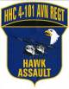

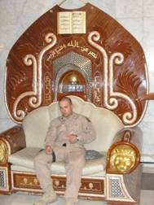

CPT Jeff Stone a la Al Bundy (on Saddam Hussein’s old throne)
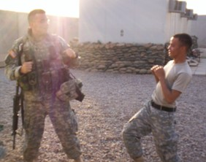
SPC Mabry and PFC Vollmer (floatin’ like a butterfly, swingin’ like a bee)
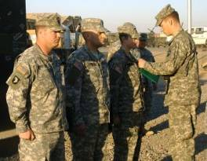
SSG Robertson, SSG Defibaugh and PFC Maguire
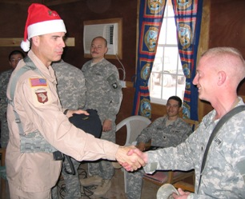
LTC Fish a la Santa handing out “Wings of the Eagle” Watch Caps – gifts from the Jeremy Wolfe Memorial
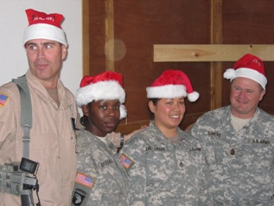
Santa and His Elves (SPC Marshall, SSG deLeon, CSM Sowers)

Happy New Year to everyone back home. 2006 has started off well for all of us over here. With the holidays finished and election season over, the mission load has once again picked up and we are back to flying a full mission load. I know all the guys are happy to be busy with flying again. Since it is the peak of rainy season, we received several days of hard rain and the living and working areas have been a muddy mess.

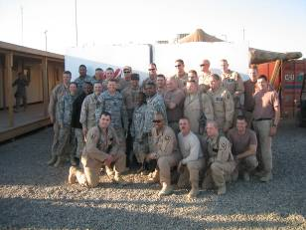

Also in January, we say farewell to CPT Robert Yopps as he leaves to go work in the S3 shop as a battle captain and we are receiving 1LT Richard Koch from Delta Company. SPC Gomez is now a part of Charlie Company to help fill shortages over there. More guys are continuing to cycle home on R&R leave. Both Shawn Fogarty and Carl Barber are back home for the births of their babies and J.D. Hollandsworth will not be far behind them.

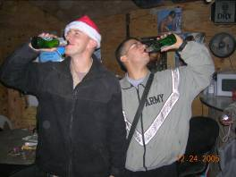
Also noteworthy, is the fact that we are now a quarter of the way through the deployment. I hope that time has passed as fast back home as it has over here. Again, we all thank you for the continued support from back home. I can assure you that it makes a huge difference to us over here. Until next month.

CPT Brian Ward
1SG Migelangelo Salinas
“Shoot ‘Em in the Face.”
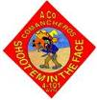

KINGSMEN
Dear Friends and Family of the Kingsmen,
We hope this letter finds you all safe and sound as we begin a new year in Iraq. It was an extremely busy holiday season for the Kingsmen as the local government began the election process and many of our nation’s leaders took an opportunity to visit the troops that are deployed here. It has been a long couple of weeks marked with endless air missions and busy skies. As always, the unit endured the worst but performed the best. As the cold and rainy winter weather of Iraq slowly sets in, we find ourselves getting some much needed rest and a small break from the high operational tempo in which we often find ourselves.
In recent weeks, the Kingsmen were chosen to conduct air missions in support of The Vice President of the United States, the Honorable Dick B. Cheney; as well as the Secretary of Defense, Donald Rumsfield. You should be very proud of the men and women in this unit, and the extremely professional and precise manner in which they conducted these missions. The company was called upon to transport our nation’s leaders through the skies of Baghdad and we did so with class and style.
We have a few new Soldiers and families to welcome to the Kingsmen Family Readiness Group (FRG). 1LT Leah Shubin is our acting Executive Officer and Training Officer, PFC Anthony Pringle and PVT Brent Dixon are both doing a great job as door gunners, and SPC Karl Lucero is our newest crew chief. We expect great things from each of them and hope that the good work they have done for us already will continue in the future.
Congratulations goes out to SPC Dennis Ramos and SPC (P) William McDowell, who have both re-enlisted since our last update. We appreciate their commitment and dedication to the Kingsmen and look forward to being able to continue working with these great Soldiers! In addition, SPC (P) McDowell has been selected for promotion to E5! Also, we are extremely proud of SGT Cole Schnoor has been nominated on behalf of the Kingsmen for the Army Aviation Association of America (AAAA) as the “Crewchief of the Year.” His work ethic and devotion to this company is beyond compare and we wish him luck throughout the process. The Kingsmen are proud of these Soldiers and their great accomplishments!
As always we are thinking about you and miss you very much. Keep us in your thoughts and prayers and we will continue to serve with pride and distinction.
Sincerely, CPT Mike “Jethro” Stull

BLACKWIDOWS
Greetings to all BLACKWIDOW friends and families! It’s been an exciting month. There is no way to summarize all that our great Soldiers have accomplished, but I’ll try to hit the highlights.

We’ve had some new arrivals that I’d like to welcome; 1LT Spanton has returned from D Co. as our XO. Unfortunately we had to send 1LT Mayo to D Co. I hope he enjoys his new position and we look forward to seeing him continue to fly with us. Additionally, we welcomed 1LT Matthews who is joining us from brigade staff, who will be heading up our flight operations section. CW2 Loree rejoined the unit and will continue to do great things for us. We’re glad to have him over here with us.
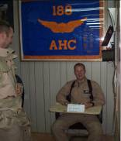
We’ve been fortunate and have added two new door-gunners to the Blackwidow team; SPC Gomez from 3-101 and PFC Passano from A/563rd. Both are helping out tremendously.

SPC Dick re-enlisted for six years, a bonus and the school incentive. He and the Army made out very well.

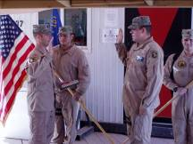

Our guys had a very exciting couple of days with Jesse James, the star of “West Coast Choppers”. We had the opportunity to fly him and his crew around. After the flight his crew provided t-shirts, hats, and some Soldiers had artwork painted by, Pete, Jesse’s graphics guy.

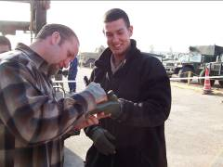

Another proud moment for the BLACKWIDOWS was when we received the 188th AHC colors from A/4-3 “Spiders” (formally 9-101). The BLACKWIDOW lineage traces back to 1967 when the company had two platoons of slicks and one platoon of gun-ships known as the “Spiders”. The 188th history dates back to when it was constituted in 1942. CPT Preciado presented the colors to C Co before he and the “Spiders” departed Iraq after a year-long deployment.
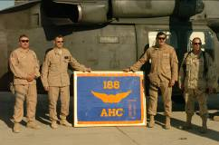

I’d also like to say farewell to CPT Jones and give her our best wishes in the Brigade S-4 shop. It is a tremendous honor to take over such a fine unit, especially in combat.

I would like to extend a special thanks to Kim Stewart and Maria Fernandez for welcoming my wife to the FRG and all the support they have given her.

Hopefully, I haven’t missed any of the big events, but as you can see BLACKWIDOWS are always on the go. Jennifer and I look forward to meeting and getting to know all of you.

CPT Brian G. Wood, CDR
SFC Scott Brown, 1SG


Charlie Co
4-101
AVN

DESPERADOS
December and the beginning of January brought more work and a little play to the Delta Company life. It brought more changes, too. 1LT Rob Wolcott replaced 1LT Dave Spanton as the Company Executive Officer. Dave is moving on to Charlie Company, and we wish him the best of luck. 1LT Richard Koch, the Shops Platoon Leader, will be leaving as well, to be replaced by 1LT John Mayo. A long workday leaves little room for relaxation, but the holiday season brought with it some good cheer. LTC Fish presented the company with custom sewn cold weather caps, emblazoned with the “Desperado” name and the 4th Battalion Eagle, a welcomed gift on Christmas Day. 1LT John Granlund and 1LT Koch even pulled a guard shift that night, freeing up a slot for a couple Soldiers to celebrate the holidays. The DFAC was full of holiday spirit as the staff decorated for the occasion, with lavish sculptures and a hearty meal.
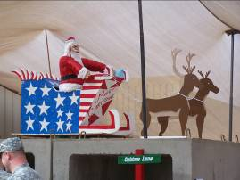

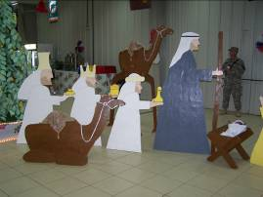

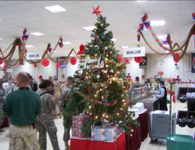

When the Company was told that there was a mandatory event on Christmas night, the last thing we were expecting was a bit of fun. SPC Bayne belted out “Jingle Bells” while LTC Fish and CSM Sowers turned the evening around by presenting us with the new PT caps, and even offered to let someone sit in the Sergeant Major’s lap! The last person anyone expected to take up the Santa challenge was Captain Hathaway, but she bravely volunteered for the dangerous mission.

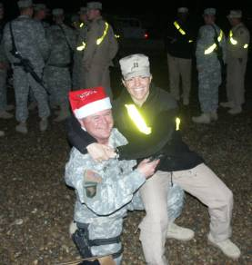

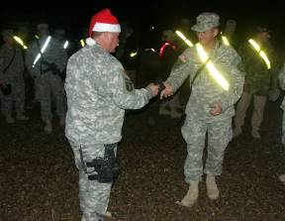
SSG STERLING RECIEVES A DESPERADO PT CAP
FROM CSM SOWERS
Afterwards, the soldiers of D Company gorged themselves on leftovers from the main meal which took place earlier in the day, and headed off for another work day at the hangar.
The personnel of the company continued with their professional lives as well. Promotions, reenlistments and moves within the Battalion continue as normal, along with boards and the race for promotion points.
We congratulate PFC Spencer Bush on his promotion to SPC! He continues to work hard and is a great asset to the Company.
His friends attended the promotion and Captain Hathaway had the honor of bringing the young soldier to the next step in his career.
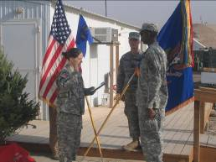

SPC Larson earned the coveted title of “Soldier of the Month” while PVT Cruz prepared for the upcoming soldier of the month board. Good luck! Thanks for making the company look great during the boards!
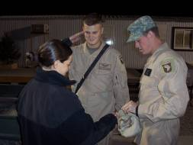

SSG Hurst made a valiant attempt to give up tobacco. However, 72 hours into the operation, the pain that it caused those around him was too much, and Hurst was command-directed to resume his nicotine therapy. We commend this attempt, and hope that at some point in the future he is able to complete this mission!
SPC Cho took a ride in a blackhawk for the first time to see if he was up for the experience. He “burped a lot” and “almost lost it” but managed to make the flight without actually seeing his lunch from earlier in the day. Congratulations, Cho! He says that one day he hopes to be at the controls of the aircraft, and we wish him luck with that dream.
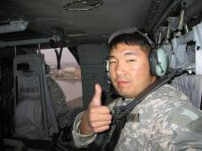
His technical supply partner-in-crime, Private Cruz, took a trip to Baghdad to get his passport, and we had some problems getting him to come back. He called it “really nice” and asked to “stay, everything’s free and nice.”

Specialist Wilcox reenlisted for another 5 years! We congratulate and thank him for 12 years of service and his decision to continue to serve our Army at war.
It’s hard to believe that we are already beginning the new year. With the battalion flying over 5,300 hours so far in theater, it’s no wonder how the time seems to fly by. The Deperados definitely have enough work to keep busy. Thanks to the families for all the Christmas packages! There was certainly no shortage of cookies around the hangar. It seems we’ll be beefing up our PT program to shed the extra pounds! Keeping looking for more updates on the Desperado website. Till next month. . . .

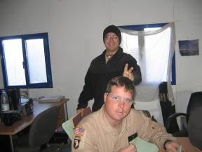
PC shop’s Mini-Hurst (PFC Phiffer) harasses
SSG Hurst during a nicotine fit.
CPT Rachelle Hathaway
Desperado 06

FOWARD SUPPORT COMPANY

Commander’s Corner
Dear FSC “Workhorse” families,
Another furious month has passed us by. January has come and gone in the blink of an eye. It is hard to believe that we are already ¼ of the way through the deployment. I think the best part of writing my blurb in this newsletter each month, is that I know that we are one month closer to going home. As always, I would like to extend thanks to the excellent Soldiers in this Company for all their hard work over the last month. Without them, the battalion would not be able to complete its critical mission of moving people around the battlefield. All families should be very proud of the exceptional job their loved ones are doing over here. I know I am. I am also impressed with the awesome support we are getting from all the families back home. Your support is what keeps us going; never underestimate the role family plays in making this deployment bearable. As we count down the months until our return, families will be at our forethought. I would also like to pass on congratulations to the Soldiers who were promoted and re-enlisted this month, keep up the hard work. Finally, I want to extend a warm welcome to the newest members of the Workhorse family; PV2 Warren gave birth to a 7lb 10oz baby boy on the 10th of January and PFC Griffin gave birth to a 6lb 8oz baby boy on the 12th of Janury. Congratulations to the Warren and Griffin families.

Respectfully,
Jason E. Ison
“Strong Families make Strong Soldiers!”

First Sergeant’s Corner
First off, I hope everyone had a Merry Christmas and welcome to a Happy New Year. As we start out the New Year the weather here in Iraq is starting to get cool and wet. While a lot of Workhorse soldiers are busy trying to get internet in their rooms, others are trying to keep their New Years resolution by going to the gym and staying fit on a daily basis. Now that we are going into the 3rd month of our deployment, a lot of soldiers will be going on their well deserved R&R leave and passes down to QATAR. Congratulations to all our newly promoted soldiers and to all who received a nice bonus when they re-enlisted.

Promotions and Awards
Congratulations go out to SGT Farmer (HQ) and PFC Tankersley (POL) on their Promotions! These promotions are truly well deserved and we look forward to seeing the increased responsibility and leadership from SSG Farmer and SPC Tankersley!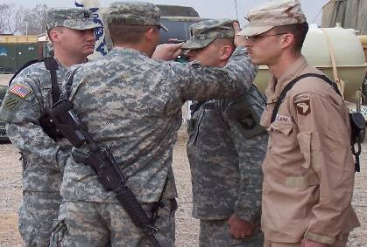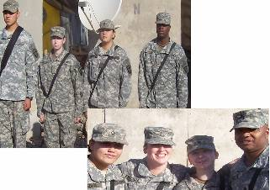
Congratulations to SSG Hildebrand, PFC Flemons & SGT Mason on their re-enlistments.
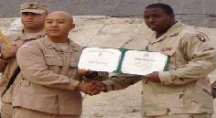

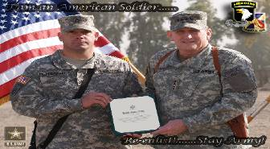
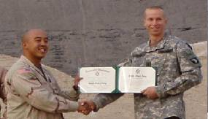

Soldiers’ Corner
This month FSC said farewell to 2LT Meddeb. 2LT Meddeb has moved over to 563rd to serve as a platoon leader in their Transportation Company. The move is an opportunity for her and a loss for our company. Good luck in your new job, 2LT Meddeb!

Although we had to say good bye to one LT, we were fortunate enough to gain another. 1LT Gray joins us from the Support Operations shop in 563rd. He has taken over as the Distribution Platoon Platoon Leader. We look forward to working with you!

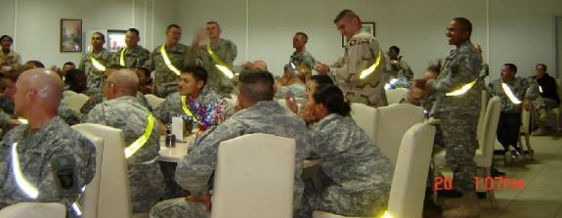

Although we had to be away from our families, we took the time to enjoy each other during the holiday season. These pictures were taken at the company holiday party/hail and farewell. We took a few moments to welcome our new soldiers and NCOs and say farewell to the soldiers that left us.

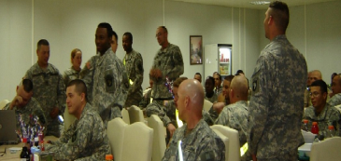

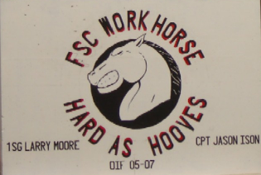
This artwork, painted on the concrete barrier in front of the company, was painted by
SPC Mercado



RENEGADES

Wow, one month has passed already since we first arrived and what a month it has been. The company arrived on December 7 and was warmly welcomed by our new Battalion. We immediately began what we call left seat/right seat rides meaning our aircrews flew with other aircrews from other companies to see the area and see how the procedures are over here. Since then, we have been flying missions every day to all parts of Iraq. Our company has been able to fly on missions with such notables as Secretary of Defense Donald Rumsfeld, actress Kelly Hu (of the movie X-Men), singer Carly Goodwin and the current Iraqi President Jalal Talibani. More importantly however, we are transporting soldiers from place to place so that they can complete their missions, and by doing so, we are keeping them off of the dangerous roads that you all read and hear about on a daily basis.

I would like to thank all of our family and friends back home for the continued support we receive from you all. Those letters, packages and emails are very well received and they keep the company going, so please continue. We all wish you warm regards and a Happy New Year.

The company has welcomed onboard three new members since arriving.

1LT Dan Deatrick of Sango, TN has joined us as the new Executive Officer. He and his wife Mandy have three children; Carter, Will and Kirstie. His previous assignment was with 159th Brigade HQs.

SPC Elias Rivera and SPC Kurt Oswalt have also been assigned to the company as door gunners. SPC Rivera is from Puerto Rico and SPC Oswalt is from Belleville, Ohio. They are both members of HHC/158th ATS and are a welcomed addition to the company.

Congratulations to SGT Chris Morris and his wife Angie for the recent birth of their son Conner who was born on December 10. SGT Morris has just rejoined the unit and we are glad to have him back for his expertise and all around good humor.

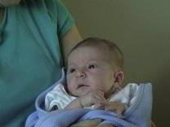

The company has been able to drop a few “candy-bombs” out in the country. These basically consist of a Ziploc bag with candy, treats and small toys. We attach a fluorescent colored streamer to it so that it is easy to see and when we spot small children who are usually very excited to see us and waving wildly, we drop a few candy-bombs in their general area. If there are some children back home who would like to put some of these together and send to us that would be great. We will take them and distribute while we are out flying. And, for every child that sends us a package of candy-bombs, we will send you a picture of your candy-bomb being dropped from the helicopter. Just send your email address along with your package. We will also keep track of how many we drop so we can report this to you monthly.
Jo Baker continues to do an excellent job as the leader / moderator for the FRG. If you have questions, comments or concern, feel free to contact her or the Commander.
tjbaker66@insightbb.com
502-647-7725 (home)
502-395-3332 (cell)
mark.brozak@us.army.mil

Renegade 06

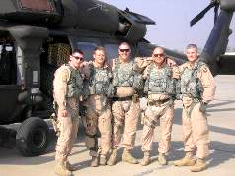
Crewmembers WO1Chad Russell, SPC Jay Stevens, SSG Brad Grigsby, 1SG Mark Newby, and CW3 Keith Baker at Al Kut.


One of our aircraft flying over the Green Zone.

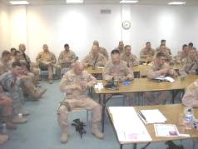

Some members of the company during a pre-mission briefing.

Rear D
Friends, Families and Soldiers of the Wings of the Eagle Battalion,
Hello from the Rear Detachment. As I said last month, we are beginning to focus on facility maintenance in the rear. There have been some exciting developments in that arena. A meeting took place with Mr. Zientek, the Sabre Airfield Manager. It looks like an initiative is going to be passed in order to bring electrical outlets into the hangar so life will be much easier for our aircraft maintainers to work on our fleet of aircraft.
In order to keep the ground mechanics happy, there have also been strides taken to improve the motorpool. LTG McNeil made a visit to Ft. Campbell recently. One of the areas he focused on was the conditions we are asking our mechanics to work in. He inspected a motorpool in the Division and was not happy with the working conditions. DPW is currently working on a plan to basically gut our motorpool and bring it up to modern day standards.
The families continue to hang in there throughout this deployment. R and R leave is in full swing, so it is an exciting time to see familes reunited a time. We are also currently working to try to reserve the Ft. Campbell Video Teleconference machine so families can have a live meeting and teleconference with their loved ones overseas.
Finally, it has been a busy months for new mothers in the battalion. Congratulations go out to PFC Crocker and his wife, PFC Warren, PFC Winley, and PFC Jones. Welcome to the new world of sleepless nights.
CPT Mike Clark Rear 06
SFC J.T. Williamson Rear 07

