4-101 AVN REGT

Volume 1, Issue 5 01 MAR 2006

Inside This Issue
Commander Comments
Company Newsletters
Change of Command

News

FROM THE COMMANDER:


Dear Wings Families,

Another month down and we’re quickly approaching the halfway point in the deployment. R&R leave is ongoing in earnest now. We’ll max out the number of Soldiers gone from now through July and really wind down during the month of August as we begin our prep to redeploy. I love the sound of that word, “redeploy.”
Our work here continues and we hit several high marks during the last month. Notably we flew our 10,000th hour in just five months on the ground—that’s twice what we fly in a year at Fort Campbell. Promotions and reenlistments have also picked up. Most of the Soldiers reenlisting are receiving a sizable tax-free donation to their bank accounts.
Your Soldiers continue to impress all that come in contact with them. The high pace of operations continues and the flight crews have begun supporting units out of 4th ID as well as the rest of the Mutli-National Corps in and around our area of operation. Of note, we had the opportunity to fly many entertainers this month including Montgomery/Gentry and of course, high-ranking civilian and military figures. The maintainers continue the yeoman’s work that allows us to put safe aircraft in the air everyday. Our fuelers keep the fleet flying, not just our aircraft, but all of the aircraft in TF Thunder and other units in and around Balad. It is truly a team effort—a team effort that makes me proud everyday.
I’d like to give special thanks to the Rear Detachment and the FRG’s for their continued support. You all make our job here so much easier because we know all is well at home. I hope you had a great St Paddy’s Day and remembered to wear something green...we all were!

W06
LTC Tony Fish

HAWK ASSAULT!
Dear Hawk Family,
It has dried out and it’s warming up! As we approach the midpoint of the deployment we’re enjoying a few weeks actually enjoyable warm weather… dreading the heat to come. The battalion is on its way to breaking Army records for hours flown and has added tactical Air Assaults to the mission set. The Soldiers of HHC continue to impress with their resolve to provide professional support enabling the battalion’s success. The S1 section is currently processing over 700 awards recognizing the achievements of the Soldiers of 4th Battalion, in addition to all their work supporting R&R Leave, passes to Qatar, mail distro and everything else they do. The S3 section continues to bear the staff’s brunt of aircrew mission support with flight following, meeting air mission coordination requirements and providing the essential link between the flight companies and the Infantry we’ve begun to habitually support. The S6 section helped make the living area cyber café and phone center a reality – SPC Lauren Kinnison’s hard work was indispensable. The rest of the section looked like a chain gang digging hundreds of feet of trenches and laying PVC piping to run fiber throughout the battalion. The whole purpose was to support bringing the battalion’s secure and unsecure internet and phone lines up to code and up to speed! When the project is complete, the entire battalion, to include the maintenance company located on the airfield will be connected through high speed fiber optics! The Unit Ministry Team put together a Duty Day with God event offering Soldiers a chance to see some of the sights in the Baghdad Green Zone (Presidential Palaces, Crossed Sabers, etc.) with a focus toward revitalizing their spiritual lives. The Supply and S4 sections continue to support the needs of the Soldier – ordering and issuing new uniforms, supplies, fulfilling contracts to meet the battalion’s needs for everything from printer cartridges to generators. SGT Kim Flemings has been a one woman show, working her tail off to make mission for the company and battalion with regards to Soldiers reenlisting to serve their country and make the most of the incentives the Army is offering for their services. The S2 section continues to provide intelligence updates and threat briefs for every mission that flies. The medics are all on leave – save Doc Savel who was kind enough to share with the battalion leadership his fascination with hemorrhoids in the last Command and Staff, showing what an anal scope looks like and how they use it to identify internal hemorrhoids. Neat show-and-tell Doc!
The Battle of the Biceps competition went down this month with competitors squaring off to knock out as many single bar curls at 25% body weight for women and 50% for men. CPT Erica Adler knocked out 62 reps, SPC Lauren Kinnison had 52, SFC Garry Riley 23 and CPT Paul Savel cranked out 47.
CPT Erica Adler, SGT Lesley Martinez and SPC Linda Marshall led the Lady Eagles (159th Women’s Basketball Team) to the finals – taking second place in the league. CPT Adler and CPT Clay Livingston were All Stars in the biggest sporting event LSA Anaconda has seen since – well – last year’s All Star Game.
Congratulations to SSG Spigner-James who reenlisted indefinitely with her husband while overlooking the airfield from the top of a Hardened Aircraft Shelter on the airfield. COL Colt reenlisted SGT Snedden as the 301st Thunder Brigade Soldier to reenlist since we deployed. We honor and thank these Soldiers for extending their commitment to serve our great Nation. Congrats also to SGT Tashi Namgyal, SGT Alex Janssen, SPC Lauren Kinnison and SPC Terry Vollmer on their promotions this month.
We can not express adequately how much we appreciate you, our family and friends back home, who support us. Your letters, packages and e-mails raise our spirits and encourage us to persevere. Thank you for caring so much for your Soldiers – thank you for your faithfulness and support!

God bless and be safe on the home front.
CPT John Wilson “Hawk 06”
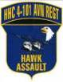
1SG Benny Stephens “Hawk 07”

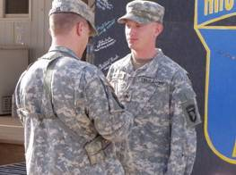
SGT Alex Janssen receives his stripes

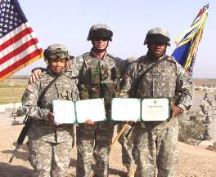
SSG Spigner-James, LTC Fish and SSG James

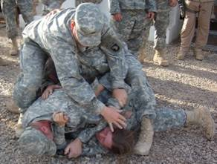
SPC Lauren Kinnison gets dog piled by the “gentlemen” of the S6 Shop
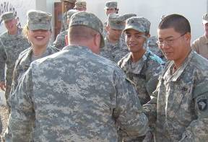
CSM Sowers congratulates newly promoted SPC Lauren Kinnison, SPC Terry Vollmer and SGT Tashi Namgyal
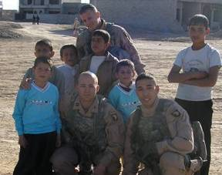
CPT Jeff Stone, SPC Alan Jones and SPC Jay Stevens interact with the children of Irbil, Iraq
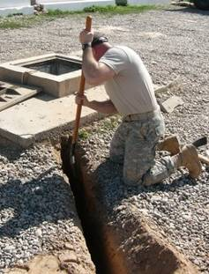
SFC Garry Riley connecting in to the drainage system to run network fiber lines to the airfield
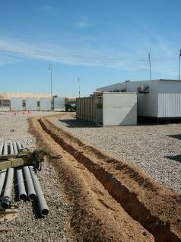
The S6 Section’s pride and joy
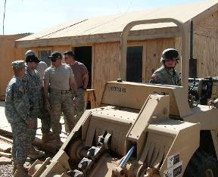
SFC Garry Riley, SGT Charles Plotz, SGT Sean Washburn

BATTLE OF THE BICEPS

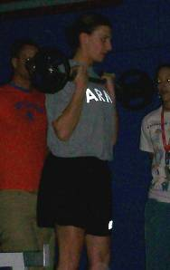
CPT Erica Adler
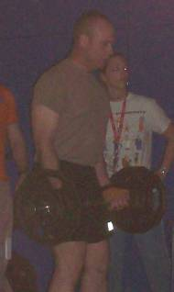
SFC Garry Riley
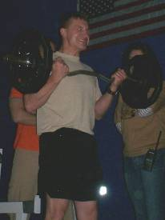
CPT Paul Savel – this might explain his fascination with hemorrhoids

Comancheros
Greeting and salutations! March has come and gone. In our marathon known as a deployment, A Company hasn’t even broken a sweat. Time is passing quickly, as I hope it is for all of you back home. The rains have subsided and in their wake, warm temperatures have followed. Already we’ve seen peaks into the 90’s. As the heat rises, the Comancheros continue to lead the way in the battalion. This month we saw the promotion of Robert Massey to Captain. Another monumental event was witnessed; CW4 Mike White was awarded his Master Aviator Wings, a feat accomplished by few in their Army career. Additionally, CW2 Richard Anderson earned Pilot in Command status.

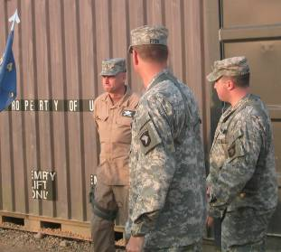
After being awarded Master Aviator Wings, all Mr. White can think about is where he’ll find his next Coke.

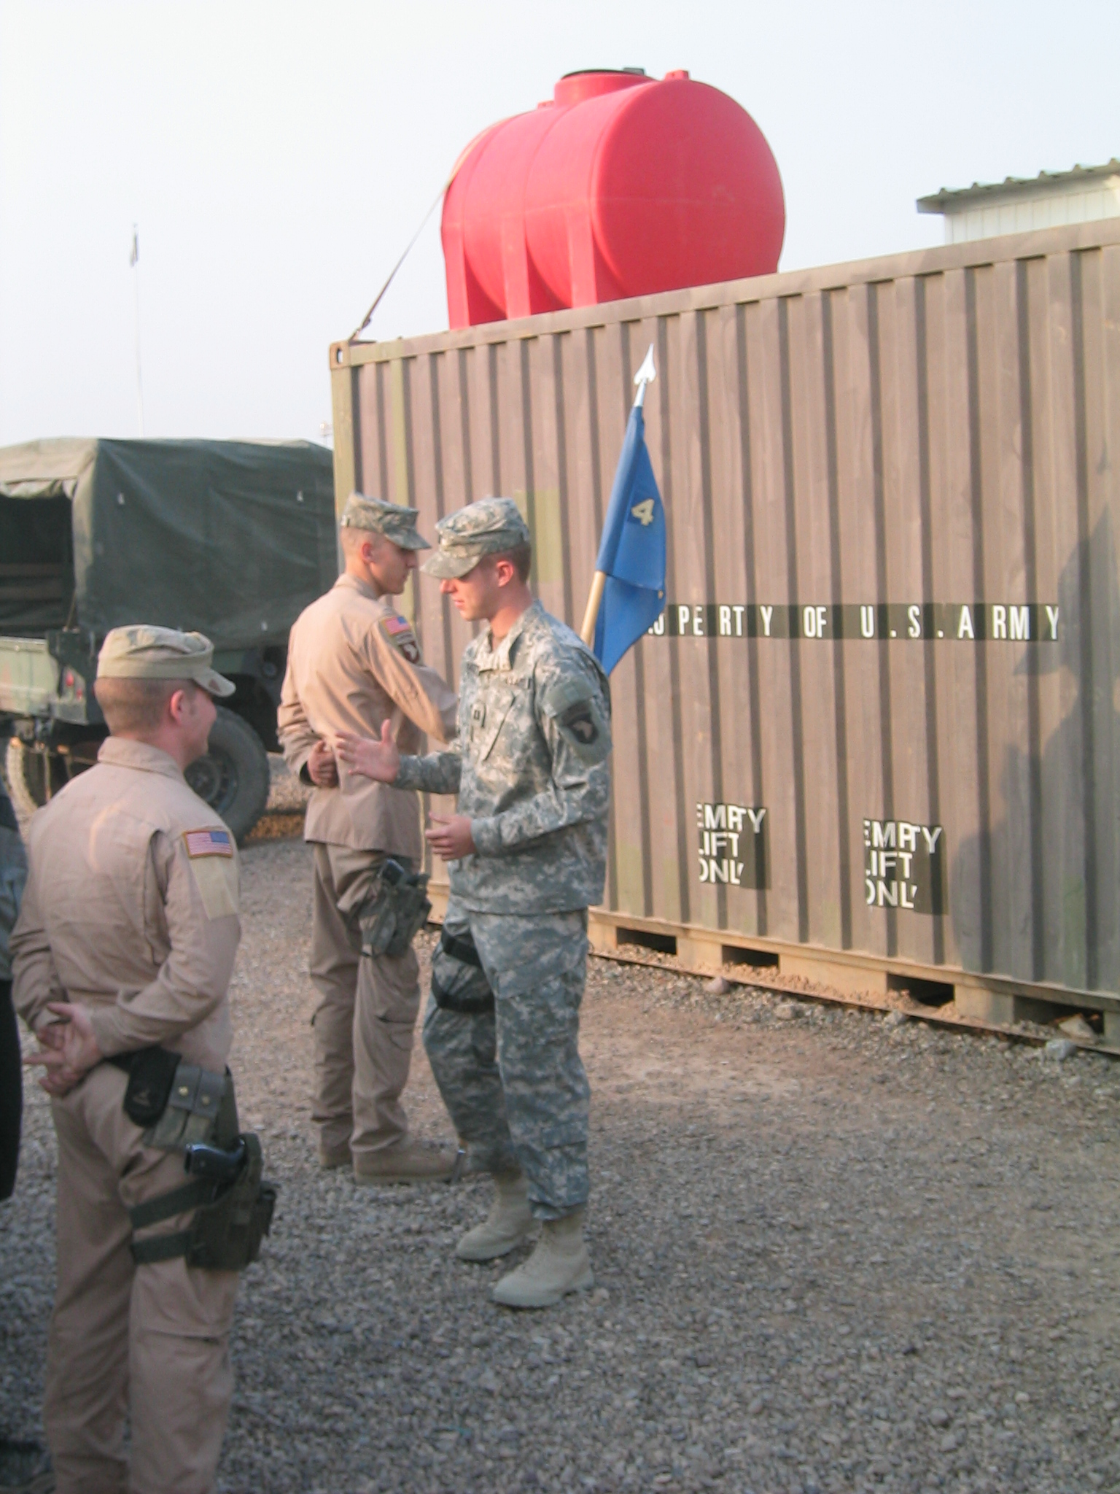

Immediately following his promotion, now CPT Massey gives his command philosophy from Chuck Norris’s viewpoint.

Aside from an extremely busy schedule, involving a record setting amount of flight hours, and the worst environmental conditions on earth, we continue to keep morale high and have a good time.

Early in the month 1LT Richard Koch and CW2 Patrick O’Neill competed in the “Battle of the Biceps”, curling ½ their body weight 37 and 39 times respectively in two minutes. 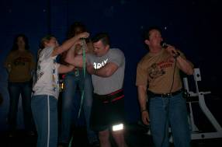

Mr. O’Neill has his cannons measured at the gun show.
WO1 Justin Mix and others attended a Montgomery-Gentry concert. This top country music band was extremely patriotic in their performance and allowed us to take a break from our busy routines and enjoy some music from home.
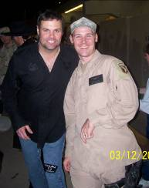

Mr. Mix and some guy named Troy at the concert.

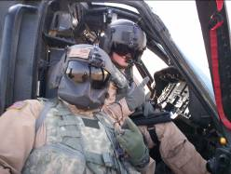
PFC Montgomery, “Monty”, sports the Darth Vader look.

As always, we long to be at home enjoying your company, carpet on our feet, a hot water heater all to ourselves, seeing grass, or just having a cold beer. The Comancheros realize they serve a noble cause that will make the time we spend at home more pleasurable for more than just our immediate families. Your ability to manage things at home allows us to accomplish the tasks at hand with unwavering concentration and effort, for this we owe you the utmost of gratitude.

Sincerely,
CPT Brian K. Ward
1SG Migelangelo Salinas
“Shoot ‘em in the Face”

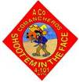
1Ss

Dear Friends and Family of the Kingsmen,
Happy Saint Patrick’s Day! Time has surprisingly been passing by very quickly, which means we’re all one month closer to our friends and family. The rain has stopped and the days are getting longer and warmer. Before we know it, the sizzling sun will be high in the sky.
The days really have been going by quickly. Throughout this challenging mission set and environment, the Kingsmen have been maintained a high band of excellence. Once again, the Kingsmen have been chosen for several important missions, some with tactical and strategic implications, and each has been performed with air assault precision. Everyday, I am amazed by the resiliency and “no quit” attitude that lives in each and every member of this great company. They never cease to impress me as each day passes. Their hard work and determination is above and beyond any I have seen. As I’ve said many times before, they have my complete and utmost respect and admiration. You all have someone to be very proud of over here.
The Kingsmen have now flown over 400 combat missions in support of Operation Iraqi Freedom, which equates to over 3,500 hours of incident and accident free flight. The battalion is still on pace to shatter flying hour records set by other aviation units in theater and that is no small feat.
Many of the Kingsmen have already had the opportunity to get some much needed Rest & Relaxation (R&R) during their Mid-Tour Leave period and many more are on their way in coming months. Enjoy your time with your soldier and take good care of them, they have certainly earned a break from a very tough schedule. Don’t forget that Video Telephone Conferences are available at the Family Readiness Center at Fort Campbell. If you would like an appointment to see and speak with your loved one, you may coordinate it through the FRG and Rear Detachment. It’s a great opportunity and very easy to do, don’t miss out!
We would like to congratulate Morgan Worthington and Michael Ash on their promotions this month to Chief Warrant Officer Two. Attached are some pictures of the debauchery that followed. Morgan was promoted on March 3rd and Mike was promoted on March 12th. CW3 Joe Hetrick, the Standardization Instructor Pilot for the company, had the honor of pinning on their new rank.
As always we are thinking about you and miss you very much. Keep us in your thoughts and prayers and honor us by living in peace at home; and we will continue to serve with pride and distinction.
Sincerely, CPT Mike “Jethro” Stull
Blackwidows

Hello to all BLACKWIDOW friends and family! This has been another great month. I will briefly try to explain the highlights the company had done.
This month we have welcomed two new arrivals, SGT Chad Hostetter and CW2 Mark Robinson. SGT Hostetter is joining us from the Replacement Detachment back at Fort Campbell. His background in aviation maintenance should prove to be a valuable asset to Charlie Company. He is completing his academics and will begin flying with us shortly. CW2 Robinson is joining us straight out of Flight School. However, he is not new to the Army. He has served previously with the 502nd as a Fire Support Officer. We are glad to have him and welcome him to the Blackwidow family.
Recently 1LT Radtke and CPT Ballard have made several trips down to Kuwait to take aircraft into maintenance. They both took several days longer to return than scheduled. Both of them had the same excuse. They blamed it on aircraft and weather problems. We all suspect it something to do with the Starbucks coffee they have down there.
After thorough check-rides and evaluations by our diligent Instructor Pilots, CW2 Jamie Ludholtz and CW2 Mike Downing have progresses as our newest Pilots-in-Command.
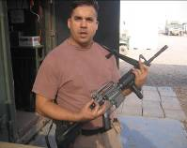

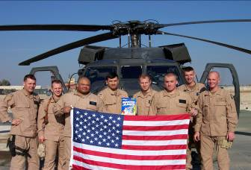
Currently 1LT Spanton and CPT Ballard are in the process of going through a Platoon Leader handover. 1LT Spanton will be taking over 2nd Flight from CPT Ballard who in turn will be taking over as the Charlie Company Executive Officer.
Several of our Soldiers had the opportunity to go see the country band Montgomery Gentry. Some of the soldiers who were able to attend had the opportunity to meet the members of the band and get their autographs.
Finally, I would also like to take this time to wish the Blackwidow family a Happy Easter!

CPT Brian G. Wood, CDR
SFC Scott Brown, 1SG

Charlie Co
4-101
AVN

DESPERADOS
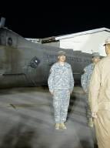
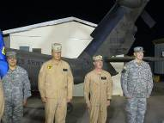
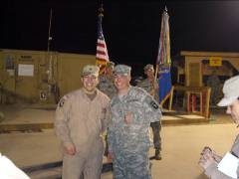
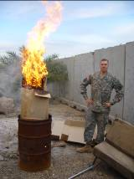
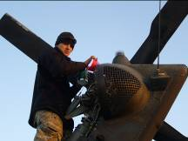
Another month gone and the Desperados are a little bit closer to getting home. The wet season is gone and the dust has begun to show itself; the temperatures have begun to climb and the wind has begun to blow, beginning to “brown out” the airfield.

Despite the shift in weather, the first day of March was a happy one for many of the Desperados, who received awards and much deserved promotions. Privates First Class Maguire, Garcia, Lopez and Alvis were all promoted to Specialist. Specialist Gedman has joined the ranks of the NCOs with his promotion to Sergeant. Sergeants Davis, Hartley, Leahy and Benitez were promoted to Staff Sergeant. To top off the evening, Staff Sergeant Mihalko was FINALLY promoted to Sergeant First Class, a much deserved and long awaited honor. He continues his devoted and exemplary service as the Shops Platoon Sergeant. Gedman and Benitez also did an honor to the service by reenlisting. 1LT Wolcott is finally flying with Pilots in Command, having attained RL1 status, and is enjoying himself immensely. He also discovered the burn barrel and hasn’t been seen since. 1LT Mayo, Shops Platoon Leader, is happy since he is now on leave, spending time with his wife and family. First Sergeant Paul has continued to fine tune his carpentry skills, building a wall for the headquarters trailer, and 1LT Mayo managed to construct a large shelving unit for the same area, a feat that took the better part of two days. We learned a great deal about the extent of Mayo’s vocabulary. Lymon and Larson exploded a tire on their truck, forcing them to walk back from the airfield. Their arduous journey taught them a lot about a life and the value of a proper PMCS. SPC Garcia and PFC Murphy, during a wind storm blowing at some 50 knots, decided that they would “watch the dust” from the top of the HAS. This would not have been so tragic, had the Battalion Commander not caught them. However, the story is made funnier by the fact that LTC Fish said that it was “a guy and a girl” on top of the HAS. We have yet to discover which one LTC Fish thought was “a girl”. Neither Garcia nor Murphy will admit to being the aforementioned female. We still have not found out how aircraft get fixed at night; however, we believe someone has been repairing them during the hours of darkness. Since we have been unable to identify any personnel responsible for such activities, we shall attribute night maintenance to friendly Iraqi elves that live in the cavernous HAS. We will continue to attempt to capture them on film, however all of our previous attempts have failed.

Fix Em or Die!
DESPERADO 06

Foward Support Company

Commander’s Corner
Another month has come and gone in the blink of an eye. It seems like months are passing by like weeks over here, and I only hope that it keeps going that way. This month has definitely been a lot less eventful than last month, especially in the weather department. If the weather stayed like this all year long, we would all be a little happier. Currently we are in the mid to upper 70’s on a daily basis, but it won’t take long for the mercury to start hitting triple digits. As hot and uncomfortable as it is going to get, at least we will know we are that much closer to being home. And of course, that is everyone’s ultimate goal….to get this deployment over with.
As always, I would like to pass on how proud I am of everyone in the company. Each and every Soldier continually does everything asked of him/her to ensure that the battalion continues to fly its critical missions. You should definitely be proud of them as well. And of course, I am very thankful to all the FRG leaders for volunteering their time to help out Workhorse family members.
I have plenty of good news to pass on for this month. First off, I would like to congratulate SPC Denham and SPC Gomez on their promotion to SGT, and PFC Tripp and PFC Wampler who were promoted to SPC. All of them are very deserving individuals and great assets to the company. I would also like to extend a thanks and congratulations to SSG Miller, SGT Kauffman, and SPC Prevatte for their reenlistments this month. All three received some money for their reenlistment, from SSG Miller’s one dollar to SPC Prevatte’s $9,000. SPC Prevatte will also be reclassing from a 92F(Fuel Handler) to an 11B(Infantry) when we return. Again, congrats to them all and good luck to SPC Prevatte as he undertakes the task of being an infantry Soldier.

First Sergeant’s Corner
Its getting to that time of year when the temperature is rising. Soldiers need to watch their battle buddies and ensure they stay hydrated. All of our Workhorse soldiers are still doing an outstanding job!! Their support to the Battalion and the Brigade is definitely not going unnoticed. I would like to congratulate all of the soldiers that were promoted on the first of the month and especially the soldiers that re-enlisted to stay with America’s best fighting force. Everyone seems to be enjoying the R&R leave, a little break that is well deserved for all. Finally, thanks to all the Workhorse families for all their support to the soldiers.

Congratulations to SPC Gomez (MP) and SPC Denham (DFAC) on their promotions to SGT. Congratulations also to PFC Wampler (MP) and PFC Tripp (POL) on their promotions to SPC. These deserving Soldiers have done some great things out here and we look forward to seeing their continued accomplishments.
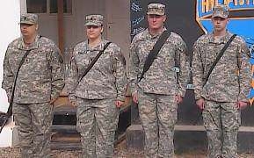
SSG Miller (HQ-left) re-enlisted on February 21st. This was his 8th and final re-enlistment. Thank you for your service and dedication
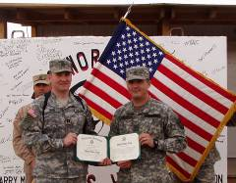
SGT Kauffman (Distro) re-enlisted on March 8th. He has just attended the Retention NCO school and we are happy to see him stick around!

CP Respectfully,
Jason E. Ison
“Strong Families make Strong Soldiers!”


PATHFINDERS
Pathfinder Families and Friends,
Thank you very much for your steadfast support. I know that you all are busy back home taking care of everything for us, but I really appreciate the volunteers who make the FRG a great institution. We have been busier as of late. All of the guys have been involved in some sort of mission. Whether it be our primary mission of securing the General Officers or conducting our old time mission of reconnaissance, the guys have done s super job. I hope that you have had the opportunity to use the VTC, I know that I really enjoyed it! There are more opportunities to use the VTC as well. Now that we have internet in our barracks, we will be exploring the use of web-cams, so we can have our own VTCs. I am not sure how well they will work because our internet connection is super slow. We shall see.
We are past the half-way point now and there is already talk of re-deployment. I still expect us all to be gone for a year. So if you hear any rumors about coming home early, they are probably not true. We are planning to "early retrograde" some equipment this summer, but we have no plans to send Soldiers home early. I wanted to make sure that you all understood that, so that there were no hurt feelings due to the rumor mill. I did hear that the FRG was planning the re-deployment party, and I thank you all for helping out in that. I hope we have a great event where we can all have a good time together.
- CPT Mike Wiser

RENEGADES
Greetings again from Balad, Iraq. The company continues to conduct its mission here in the cradle of civilization, and do it well.
The company has started sending soldiers home on their mid-tour leaves already. It is taking about 2 days of travel for the soldiers to reach home, but that does not count as leave time. SGT Hagan was our first to go home and return so we are now all anxiously awaiting our turn. The way it works is that when the soldier goes on leave, he will travel from Balad to Kuwait to catch a plane into Atlanta, GA, usually via Germany. Once in Atlanta, the soldier then will catch a plane to their ultimate destination, which will most likely be Louisville, Lexington or Cincinnati which is of no cost to the service member. Once they arrive there, the soldiers leave will start at midnight after arrival. The same for the return trip, the soldiers leave ends upon return to Atlanta, so his travel time back to Iraq does not count against him. This way, the soldier gets a full two weeks at home.
I just want you all to know that the entire company is doing an outstanding job over here. You have every reason to be proud of not only your soldier, but the company as a whole. I want to thank you all for the continued support we receive from home and ask that you continue that. Know that we think of you all often and anxiously look forward to our return.
A big congratulations goes to several members of the company this month for being promoted to the next higher pay grade.

Matt Willey has been promoted to Chief Warrant Officer Three and has also been awarded his Senior Aviator Wings which denotes at least seven years of aviation service and 1,000 flight hours.

Also being promoted is Dale Adkins from Sergeant (E-5) to Staff Sergeant (E-6).

Tom Simpson has been promoted from Specialist (E-4) to Sergeant (E-5).

These soldiers are all very deserving of their promotions and we wish them success with their new rank.


SGT Casey handing out candy to young children at An Najaf, Iraq.

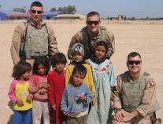

Chad Russell, Jay Stevens and Daryl Casey posing with new friends. It is children like these that we drop candy to.
We would like to welcome into the company two new door gunners recently assigned to us.

SPC Dan McGuire
Dan and his wife are from Moscow, PA and have three children; Colin age 12, Margaret who is 7 and young Marin, all of 20 months old. Dan is a 15P (Aviation Operations Specialist) assigned to HHC, 158th Aviation.

SPC Raul Rosa
Raul is from New York, NY. Currently single, he is assigned to HHC, 158th Aviation as a 92A (Logistics Specialist). Before the Army, Raul attended Penn State and worked at Starbucks Coffee in NYC.
Our company had the opportunity to fly the duo Montgomery Gentry in mid-March. They flew into Balad for an MWR concert which was great. Additionally, they held up the American Flag while SGT Louis Simpson was reenlisted by WO1 Travis Rogers. In the photo L-R rear is SGT Simpson, SGT Adkins, Eddie Montgomery, Troy Gentry, and SFC Hedden. Bottom L-R is CW2 Rice, SGT Casey, WO1 Russell and WO1 Rogers.

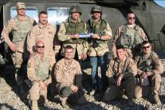

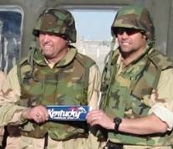

CPT Mark Brozak
Renegade 06
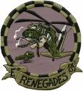

Rear D
Soldiers, Families, and Friends,
March has continued to be a month of working with the Department of Public Works and Self Help Sections at Ft. Campbell in the pursuit of improving the facilities in the Rear. The Pathfinders finally got a sign in front of their building, so they will no longer be able to hide out in secrecy.
DPW has responded well to some of the work orders that have been submitted. Contractors have made site visits in regards to installing a sprinkler system in the Butler Building, installing new voice and data drops at the hangar, installing male and female showers at the hangar, installing pull up and dip bars for the Pathfinders, and mounting the brand new 32” staff duty television on the wall. It has also been confirmed that work on renovating the motorpool will begin on 01 MAY 06. Hopefully, the BN areas will be unrecognizable when the BN redeploys.
We did not fly the duo Montgomery Gentry this month, but we are on an incredible pace in the Rear for hours logged flying our desks. As always if anyone needs any support feel free to contact any member of the Rear Detachment.

CPT Mike Clark Rear 06
SFC JT Williamson Rear 07


Brigade BUNKO winners! Liz Savel &
Lesli DeMoss

We are gearing up for our Battalion Easter Egg-Stravaganza …April 15 (Saturday) starting at 5 PM. CPT Mike Clark has agreed to be our Easter Bunny (we should have great pictures for next month’s newsletter!!)
It’s been fun to see some of you return for R&R. Can’t wait until we are welcoming you all home for good!
Please be thinking about what kind of Welcome Home Celebration you would enjoy.
As I write this Nancy Colt, Rhonda Klinger and I are in Frankfort visiting the Renegades. What a great group!
All of the company FRG Leaders and Points of Contact are doing amazing work for you.
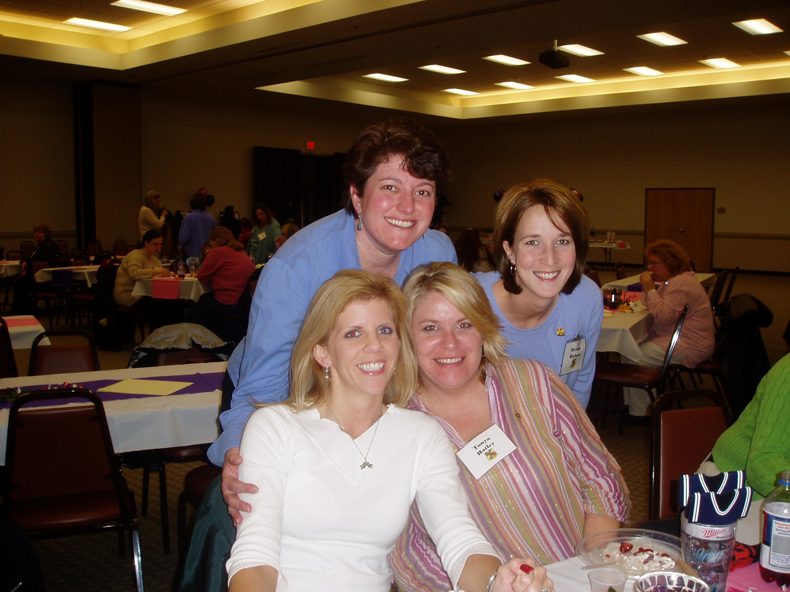
Melissa Hudson, Leslie Burks and Tanya Hatley with me at a Division Leader Appreciation.
You are in our thoughts and prayers!
Stay safe.
Judy Fish

