4-101 AVN REGT

Volume 1, Issue 9 15 JUL 2006
FROM THE COMMANDER:

Dear Wings Families,
We should have only a couple more of these newsletters “from the front.” It will be nice when our news is “home front” news. Nothing says ‘home” more than a 4th of July barbeque. While Independence Day was another busy day for the Wings of the Eagle Battalion, the dining facility went all out and offered a huge feast for the occasion. I hope you gathered with friends and family to commemorate that special day—maybe even watched some fireworks. Our celebration did not include fireworks this year…a blessing in this part of the world!
The Wings Battalion continues to surpass


milestones that just a year ago would have been unheard of…well over 21,000 hours flying, 1.8 million gallons of JP8 dispensed and operational readiness rates above 85% for both ground and air—just incredible numbers!
What’s even more incredible is the way in which your Soldiers continue to accomplish their missions…motivated, dedicated and always professional; this despite temperatures that routinely hit 110 degrees before noon. I couldn’t be more proud of the attention to detail and the focus the Soldiers continue to demonstrate, a focus we’ll need to continue until we’re mission complete.
As we start talking redeployment here, we’ve heard whispers of your “Welcome Home” plans at Fort Campbell. We love that you are planning for our return. We can’t wait to be reunited with our families. Everyday I feel grateful for all the support and love that flows to us from our friends, families and other fellow Americans.
Thanks for all you do for the Wings Battalion!

W06
LTC Tony Fish
HAWK ASSAULT!
Dear Hawk Family,
1SG Stephens and I are back from R and R Leave and getting back into the swing of things here at Balad. We returned to see the Hawk Assault Soldiers performing better than ever, notwithstanding the extreme temperatures which we are working in. The operations section continues to work 24/7 on tracking every mission we perform as well as every other task that the battalion can not really find a “place” for. The supply and personnel sections are even busier in preparation for the impending redeployment. They are feverishly closing accounts, preparing redeployment briefs and packets, and ensuring that all equipment and personnel will transition smoothly out of Iraq and back into Ft. Campbell. The Commo Shop is attempting to prepare a comprehensive summary of how to run and maintain this incredible network that they have created, a daunting task for any unit. The Intel guys (S2) are consolidating all security clearance requests, organizing classified materials, and ensuring that digital equipment doesn’t accidentally contain something it shouldn’t. Even the medics normally routine schedule in the clinic and at ranges is tweaked with additional requirements for immunizations and medical screening for all 159th Soldiers who are returning come September and October.
The point of all this is that while the deployment is wrapping up, the pace of operations is actually increasing. The first and last months of a year- long deployment are notoriously the most stressful and demanding. The process of clearing our work and living areas, packing/labeling/and shipping our equipment, training our replacements, and moving around 400 people and 30 aircraft to Kuwait is not easy by any stretch of the imagination. This is the last big “hurdle” in this deployment and we are poised for success while clearing this hurdle in no small part due to the tremendous support of your Soldier.
The communication during this process might be a little more difficult as well. Imagine the population of your neighborhood and workplace doubling one day; without any corresponding increase in the amount of structural support for that population increase. This is going to happen to our side of Balad Airbase in late August and September. As our replacements come in, we will move to transient barracks and share everything with them (gym, DFAC, MWR centers). This is going to increase the amount of time it takes to do those everyday activities we have become accustomed to. Just have a little patience. After all, the people causing the hold up are the ones who are replacing us.
It is definitely exciting to be coming home. Try to plan ahead to when your loved one is back and make sure the mundane, yet important, stuff is taken care of. For example, expired license plates, car insurance, driver’s licenses, expired credit cards, etc can all be rectified long before your Soldier returns. Get all of this done now, then you can enjoy your time off without having to worry about anything. My intent is to bring your loved one home safely, and ensure that your reunion is as joyful as possible. I plan to empower you with all the information I can possibly give you to put your mind at ease throughout this transitory time. Please let myself or Amy Stone know if you have any questions that we could possibly answer, realizing that exact dates and times for troop locations will be impossible to give for numerous practical and operational considerations. Again, thank you for all the support you provide your soldier.
Congratulations are due to CPT Chappell, SFC Sims, and SPC Lamons on their promotions this month!

CPT John Albright “Hawk 06”
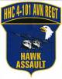
1SG Benny Stephens “Hawk 07”

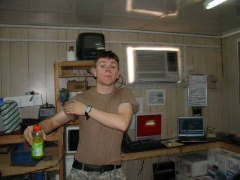
SPC Seibert caught unawares while hydrating.

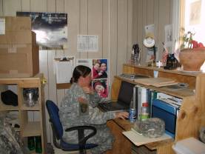
SGT Fleming intently focusing on the computer screen.

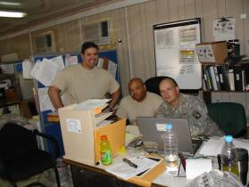
The NCO’s in the S-1 shop posing for the camera.

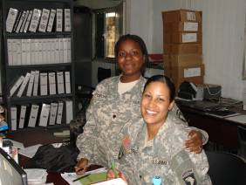
SPC Flemons looks right at home in Balad as long as she is with SPC Scott.

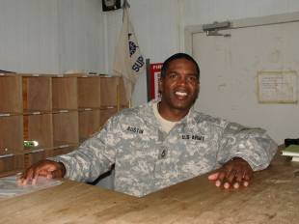
SFC Austin looking shaved and relaxed after his R&R Leave.
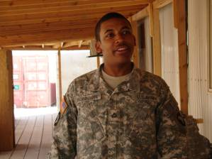
PFC Robinson ponders the meaning of life outside the TOC.
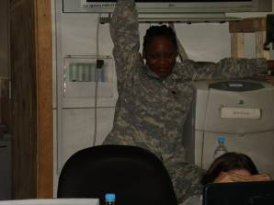
SPC Lamons strikes a pose while SGT Brownell attempt to hide from the camera (those are her hands in the lower right hand corner).
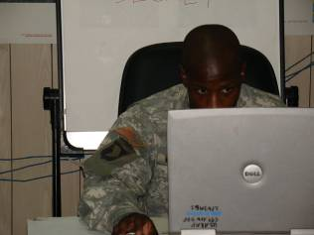
SGT Wilson attempts to beat Solitaire.

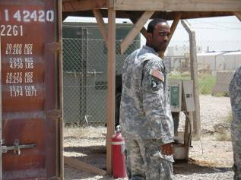
SPC Oneal realizes he’s being watched as he makes a break for it from the TOC.

COMANCHEROS

Time is passing quickly for us now, as I hope it is for you also. July has been another month of sand, dust, and heat. This month has seen the Comancheros continue their record setting pace for hours flown in theatre. The 4th of July was celebrated with a huge fireworks display – we wish. Though, they did test fire all six C-RAM anti-mortar / anti-rocket systems on the 2nd… that was impressive. Had they done it on the 4th it would have been perfect. Regardless, many of the guys got together and grilled out on the 4th and everyone in the battalion received T-shirts with the company logo on the back. These were provided by the A/101, Kingsmen and Black Widows Veterans Associations. The guys appreciated the gesture and will wear them with pride. On the 10th of July, the Comancheros flew in OPERATION AQRAB. This mission resulted in the capture of six wanted insurgents and the destruction of several weapons caches uncovered during the operation. It was an overall success and another small step toward stabilizing this country. On July 12th, Secretary of Defense Donald Rumsfeld visited LSA Anaconda. CW2 Gene DeCrisci attended, stating it was somewhat enlightening but not nearly as entertaining as he anticipated the Perfect Angels Show he planned on attending later in the week to be. The CP has become a battlefront for games of HALO while the guys sit on stand-by missions and during downtime. Sometimes the games get pretty heated, especially when 1SG Salinas gets beat over and over. Everyone enjoys when Top plays, they all know they’ll get a few easy kills.

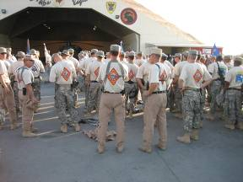The Comancheros sport their new shirts on the 4th of July.
We are sorry to see CPT Bob Massey leave the company this month as he hands 2nd Flight over to 1LT Joe Rozyckci. Bob is moving on to the staff world, currently working in the S3 shop as a Battle Captain. Supposedly, it’s a step up… but everyone knows how much he’s going to miss being taped to the porch rail on the battalion boardwalk and humiliated by his loyal and devoted Crew Dogs on a weekly basis.
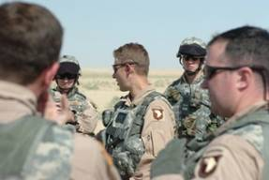
CPT Bob Massey in action
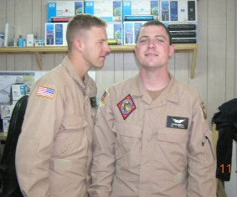
CPT Bob Massey and 1LT Joe Rozycki
We’re sorry to say goodbye to two more Comancheros but due to the circumstances, very happy to see them go. CW2 Joe Farwell and CW2 Rob Forney were among the first pilots ever to graduate from a Maintenance Test Pilots Course taught in Iraq. The two were hand selected and are on orders to attend the Maintenance Managers Course at Fort Rucker in August. Thankfully, the Army wised up and dropped the cash and the two are on their way. They’ll get a short stint at home and then finish out the course just as we return… great timing. A well deserved break for two upstanding Comancheros. Folks at home, if you see them, congratulate ‘em, they’ve done a remarkable job and we’re fortunate to have them preparing to pick up the maintenance load upon our return!
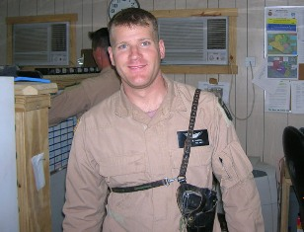
CW2 Joe Farwell – good luck at the MMC – see you soon!
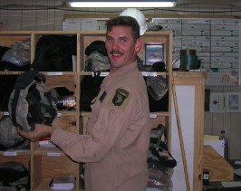
CW2 Rob Forney – good luck at the MMC – see you soon!
As always, we thank all of you back home for your love and support. Without it, we’d certainly not be doing as well as we are in spite of the circumstances. We look forward to seeing you soon.

Sincerely,
CPT John C. Wilson
1SG Migelangelo Salinas
“Shoot ‘em in the Face”

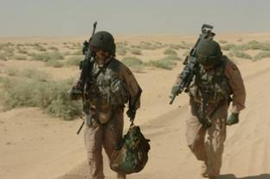
All day, every day…

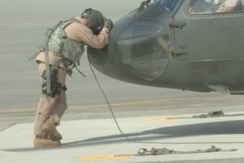
Hotter than, well… it’s frickin’ hot.

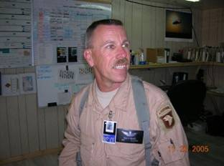
Dead man walking – it’s coming SFC Nelson.

Dear Friends and Family of the Kingsmen,

Happy 4th of July to all of you! The Kingsmen keep on trucking’ out here in the hot sun and continue our record setting trends! The aircraft have never looked better and the Soldiers are staying focused on the task at hand. Rest assured, we are thinking about you all during the few moments of spare time that we do take advantage of when able. The pool here on the airfield is a pleasant break from the hot sun and long days and many of the guys and gals been able to compete in some extra curricular activities like softball, sand volleyball, and even karaoke (although many wish that we wouldn’t)! Despite the hard work the Kingsmen are still smiling and starting to see the light at the end of the tunnel and are excited to return home to you all very soon.
I know that our return dates are on the forefront of our family’s concerns. Believe me, it’s on all of our minds as well. Our actual return dates are still not officially published, but when we know when we are coming home, you will too. Remember that this information is highly sensitive (classified) and should only come from official channels and should not be discussed unofficially. Your Soldiers will inevitably try to give you as accurate information as possible, but whatever information we have will certainly change by that time. I urge you not to trust the gossip and rumor mill that will no doubt manifest itself here in the coming months. The Rear Detachment will have the only official information and will disseminate those timelines as soon as they receive it. It will be frustrating. I ask for your patience and understanding in the weeks to come as we work through this process and as soon as something concrete is issued, we will certainly attempt to give you enough planning time to arrange travel and reservations to allow you to greet your Soldier as soon as they get off of the plane. I thank you in advance for your cooperation and understanding.
In the meantime, the Kingsmen have continued to lead the battalion and brigade in large scale air assault operations targeting insurgents and IED Cells with growing success. Our last operation was successful in discovering and destroying multiple weapons caches and the capture of numerous terrorist conspirators. It was the largest and most successful operation of the deployment to date. Great work by the officers and enlisted professionals in this company to pull together and make that mission so successful.
I would like to take an opportunity to congratulate CPT Andrew “Lief” Erickson, CPT Bryan “Bubba” Whittier, CPT Leah “Princess” Shubin, CW4 Larry “The Lima” Adkins, and SPC Phillip “Fireball” Swearingen on their recent promotions. They certainly deserve the recognition for distinguished service and are certainly capable of the increased responsibility that comes with their newly designated rank. I have no doubt that they will continue to make you proud and serve with class and distinction.
As always, thank you for your continued support; it does not go unnoticed. The stability that you provide at home serves as the foundation of our efforts and allows us to focus on our mission here. Our primary goal is to finish the mission here and return safe and sound to the families and friends that we love and miss so dearly. Take care of yourselves and each other, and we will be home soon.

Sincerely, CPT Mike “Jethro” Stull
Kingsmen 6

Blackwidows

Another month has gone by, and we are flying until the rotors fall off. We continue to support the safe air movement of troops in country. One person off the roads is another person going home to their family, and we take great pride in that. Also we found time to make it uncomfortable for the insurgents by delivering the Calvary to their front door.
This month we have the addition of CPT Granlund. He will be taking over as 1st Flight Platoon leader for CPT Radtke. We are all looking forward to having a new Captain to bring into the Blackwidow fold. CPT Radtke will take over his maintenance Platoon in Delta Company.
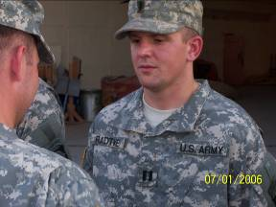
CPT Radtke being promoted to the rank of Captain.

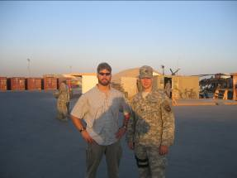
CPT Spanton and his brother JD Welsh after his promotion.

This month was a promotion blow out! We would like to congratulate our two new Captains, CPT Radtke and CPT Spanton. With four Captains in the Company we no longer have any paper work that cannot be overcome.

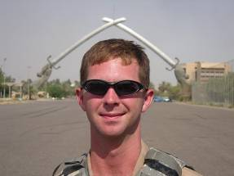
CW2 Murphy contemplating his Presidential aspirations

Also during the month of July CW2 Murphy attended a Duty Day with God. This gave him the opportunity to spend the day inside the International Zone in downtown Baghdad while discussing the spiritual situation in the Region. It was also time to bond with the Wings of the Eagle Chaplain CPT Gramling.
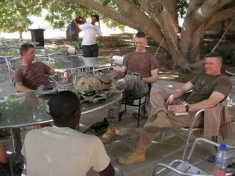
CW2 Matt Murphy on a Duty Day with God in the International Zone

As always we would like to extend our love and thanks to all the families waiting for us in the rear. The deployment is starting to draw to a close, and have no doubt that you are on our minds constantly. We are looking forward to the FRG return Fiesta.

CPT Brian G. Wood, CDR
SFC Scott Brown, 1SG


Charlie Co
4-101
AVN

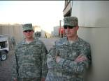
DESPERADOS
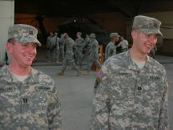
June and July brought a bit of cooler weather for a few days as well as the continued march towards the last month of the deployment. We are less than 90 days out, and the excitement is palpable. Continuing to work very hard to support the Battalion's incredible flying hour program, Delta Company remains a key enabler of the battalion’s missions.
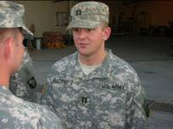
July 1st brought a flurry of promotions to Delta Company and the month of July will bring further change. 1LTs Mayo and Granlund were promoted to Captain, making 1LT Wolcott our sole lieutenant, and Phifer, Vasquez and Cruz were all promoted to Specialist. Oddly, CPTs Mayo and Granlund did not celebrate by buying the company dinner, which is strange given their vastly expanded paychecks. SGT Candiloro was also promoted to SSG, a well deserved honor.
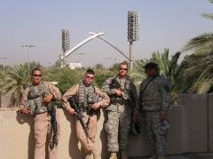
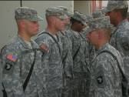
CPT Granlund is leaving the Desperado team, finally making his way to a flight company. He will be going to Charlie Company, swapping out with CPT Radtke, another newly promoted officer. CPT Radtke looks forward to coming to Delta Company, but has no real idea what he is in for. It's a good thing he's taking leave in July so that he can come back refreshed and ready to face the men and women of the Maintenance Platoon and his enormous hand receipt. CPT Granlund will be missed, and no one is sure how he will cope without having his own truck.
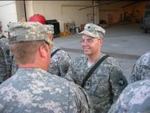
Another Duty Day with God gave our Soldiers a chance to visit other parts of the country, and once again Chaplain Gramling’s devotion to the men and women of 4th Battalion has given our Soldiers a chance to relax.
We have also welcomed eight new soldiers to Delta Company. PV2s Gardner, Leppink, Miller, Slanton, Stevenson and Williams are brought into the Maintenance Platoon fold, as well as PFC Helton and SGT Jones. We welcome them to Iraq, and thank them for showing up just in time to help pack up. The deployment tempo will give them plenty of opportunities to improve their knowledge and maintenance skills on the Blackhawk.
We are slowly starting to make preparations for the big movement home. We are preparing our load plans and containers and rearranging our equipment while sections think through everyone’s leave plans. By August, we will be fully immerged in redeployment activities.
In closing, we would like to give our continued thanks to the Family Readiness Group of Delta Company, whose tireless support helps to keep our Soldiers working hard with their eyes on a long awaited homecoming. The next few months will be very busy, but we are sure they will fly by fast given all that is to be done. We will see you all very soon.

Desperado 06

Foward Support Company

Commander’s Corner
Dear FSC “Workhorse” families,

I hope the month of July has been another successful one for everyone. It has been another opportunity for the Workhorse Soldiers to demonstrate that they are some of the best Soldiers the Army has to offer. Whether pumping fuel, fixing vehicles, distributing supplies, or checking ID cards at the DFAC Workhorse Soldiers continue to excel. For me, the month of July has been outstanding. I finally got my chance to go home on leave and spend some time with the family. And I thoroughly enjoyed the break. Now I am ready to focus on the last months of this deployment. It is hard to believe that we are now three quarters of the way finished with this deployment. Time has really passed us by quickly. The light at the end of the tunnel is definitely more than a flicker. Soon, we will be putting the majority of our focus on getting home. That will be nice change.
As usual, I would like to thank all the families for their outstanding support of this company and their loved ones. You have definitely helped to make this deployment overwhelmingly successful. I would also like to extend a special thanks to Melissa Hudson who has relinquished her leadership of the FRG. Melissa and her family will be moving to FT Rucker as her husband attends the Warrant Officer Candidate School. Good luck and thanks for all your support. We are very lucky to have Glenda Hildebrand stepping in to replace her as our FRG leader. I know she won’t miss a beat in providing great support to all the Workhorse families. I look forward to working with her.
As Always, I have some good news to pass along this moth. Congratulations to PFC Maldonado, PFC Helberg, PFC Johnson, and PFC Rodenas who were promoted to SPC and to SPC Davis and SPC Morales who were promoted to SGT. And finally, congratulations to SGT Patterson and PFC Powell who both reenlisted this month. They are highly deserving individuals and will serve the Army well in the future. Again, thanks for your support and keep us in your prayers.

First Sergeant’s Corner
I would like to say hello to all the Workhorse family and friends. Another month has gone by and we are starting to prepare for re-deployment. Congratulations to all our soldiers who re-enlisted and to all who received promotions this month, well deserved. We have had some very interesting company morale events with each platoon competing against each other for the commanders cup, so far POL has dominated. August will be the last month we will be sending soldiers on R&R leave and pass. I would also like to thank all the Workhorse families for all their continued support. Stay safe and no matter what you are doing, always think safety!

Promotions
Congratulations to SPC Davis (POL) and SPC Morales (Distro) on their promotions to SGT. Congratulations also to PFC Johnson (POL), PFC Helberg (MP), PFC Maldonado (Distro) and PFC Rodenas (POL) on their promotions to SPC.
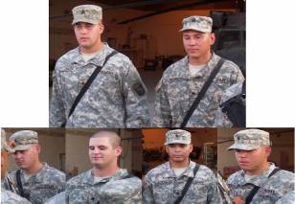

We’d like to take this opportunity to thank the two Soldiers from Distro that reenlisted this month. SGT Patterson and PFC Powell are both outstanding Soldiers that have done well for themselves and for the unit since being in the Army. We thank them for their continued service and wish them luck on their future. Thank you also to Candice, Hunter and Jackson for your support to SGT Patterson and thank you to PFC Powell’s parents and friends for your support.
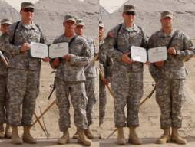

Soldiers’ Corner
Every month we do Safety Training to help ensure that we all know the right things to do in order to prevent accidents. Safety Training usually means sitting in a classroom for two to three hours while we listen to various NCOs teach us how to handle different equipment and weather conditions. This month we decided to take a different approach…
With the company pool party on the horizon, we had a hands-on Safety Day. This month we did Drown Proofing/ Water Survival. I know that that sounds a little strange in the desert, but we have more and more people spending their free time at the pool. It allowed not only for training, but gave some people a little more confidence in the water as well. Take a look at what the soldiers learned at the training.

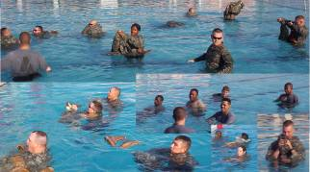

We received great instruction this month on Drown Proofing (as you just saw), but fortunately we did not have to put into action any of our new found skills at the Company Pool Party. We all had a lot of fun swimming and enjoying the food and company. There was something for everyone and a good time was had by all! We appreciate the Distro Platoon putting this event together for .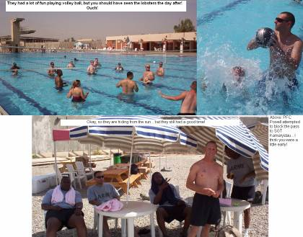

We thought we would squeeze a few extra pictures in this month where space is available, hope you enjoy them!
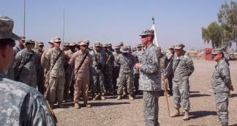
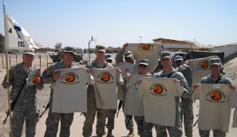

Welcome to the Workhorse Family!
CPT Ison, CDR
1SG Moore, 1SG



RENEGADES
Another month is upon us as we continue the mission here in support of Operation Iraqi Freedom. As you have heard, Iraq is hot this time of year and if not careful, it can be detrimental. However, the company is taking measures to ensure that the guys are well rested and get some time off between flights so that they are not worn out.
Some good news from the families include SSG Dale Adkins daughter Kimberly being awarded the Leadership Award recently at the Wendell H. Ford Regional Training Center Youth Camp put on for Kentucky National Guard members families. There is also a new baby in the company, Isabella Brozak, bringing the total to five the babies born since we have deployed.
Some sad news from the company is that we may have to leave five of our eight aircraft here for the next rotation of aviation units to use. As you might imagine, we are all fairly attached to our aircraft and dislike the thought of giving them away, but we do what we have to in support of the mission.
We are starting to get in the redeployment mode of thinking now. With less than four months until we depart, the company is starting to prepare for moving all our equipment and personal belongings home. More importantly, we are preparing to hand off to the next unit that is incoming so that they are prepared to take the mission and begin executing as quickly as possible. Still no word on the exact date when we will depart, but as soon as we find out, we will get that out to you as soon as we can, I know everyone wants to make plans for our return, so as soon as we know for sure, you all will know. In the meantime, there will undoubtedly be rumors circulating as to when we will eventually be home. Please, don’t get too caught up in them until we know for sure as to our return. And keep in mind, this is the Army, so there will undoubtedly be some changes. In the meantime, just know that the guys are all doing a great job over here in everything they do. You cannot find a better group anywhere else.
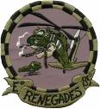
We will have an FRG BUNKO night at Jo Baker's house on Saturday, July 29th at 6pm. This is a free Bunko for all who attend and there will be some great prizes awarded, so please don't miss out on this fun event. Further details and directions to Jo’s house will be sent out soon. We will need a RSVP on this to plan for food and tables. The FRG is planning a Girls Day Out for Saturday, August 26th. This will take place at the Posh Salon in Lexington. Further details are coming and this event will require a RSVP. Please mark your calendars now to enjoy a day of pampering.

CPT Mark Brozak
Renegade 06

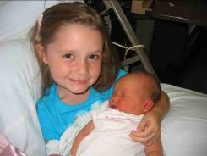

Congratulations to Mark and Kimbra Brozak on the birth of their new daughter, Isabella Annelise born on June 21 weighing in at 7 lbs 14 oz. and 20 inches long. She is being held by her big sister, Madeleine.
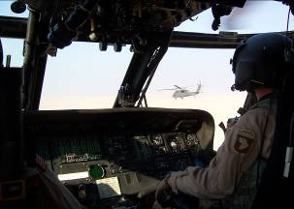
View from the back looking through the cockpit at another one of our aircraft on a recent mission.
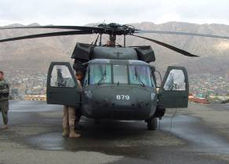
Aircraft 879 in Northern Iraq. SSG Scott Foster is the assigned Crew Chief of this aircraft.
Meet the Company

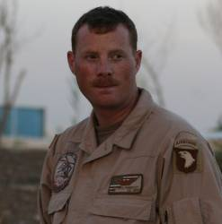

CW3 Stephen Hunnicutt
Standardization Instructor Pilot
Wife: Karen
Children: Karen, Brittany, Kaitlyn, Jonathan, Joshua, Abigail, and Joseph
Home: Owenton, KY
Age: 36
Occupation: AASF Technician- Instructor Pilot
Company: Army Aviation Support Facility
Years in the Military: 19
What he misses most (besides his family): Sitting on the front porch talking with his wife.

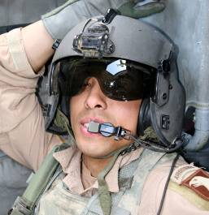
SGT Allen Jones
Crew Chief
Girlfriend: Jenny
Children: None yet, lets wait til after graduation.
Home: Columbus, OH
Age: 24
Occupation: Student
Company: The Ohio State University
Years in the Military: 6
What he misses most (besides his family): A nice cold beer.

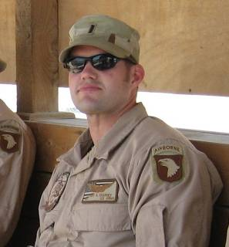
1LT Adam Kearney
Platoon Leader / Pilot
Wife: Kelli
Children: None, but having fun trying.
Home: Lexington, KY
Age: 30
Occupation: Training Technician
Company: 63d Aviation Group HQS
Years in the Military: 12
What he misses most (besides his family: Walking 5 feet to the bathroom instead of 100 yards.

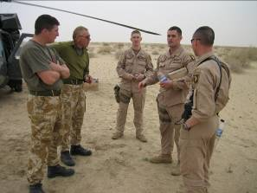
SPC John Barrett, 1LT Adam Kearney and CW2 Daric Scheiderer talk with British troops in the southern part of the country on a recent mission.

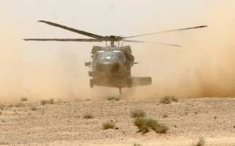
This is a shows one of our aircraft doing a brown out landing in the desert. These landings take considerable crew coordination between both crew chiefs and pilots since visibility can be severely restricted.
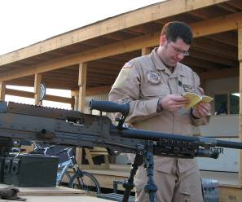
SGT Chris Morris reading the manual on our machine guns.

PATHFINDERS
Dear 4-101 Battalion Family and Friends,
I would like to thank you for all of your support during the last couple of months. The Pathfinder Company morale continues to be high and that is due to all of your thoughts and prayers. With the beginning of redeployment already in progress, morale of the men raises everyday with the thought of being home with loved ones. Our tour is slowly but surely coming to an end, just in time to beat the summer heat. With the average temperature during the day being well over 100 degrees, the men are looking forward to being home even more.
This past month has been very exciting due to the mission tempo and redeployment operations. We continued our mission of securing the General Officers and, as always, the guys set a high standard for the division. We have done several patrols in and around the surrounding area of our base, giving a helping hand to the battalion when needed. Team 3 continues to operate out of Mosul with their General Officer and all reports that we have received, show that their performance thus far has been outstanding. All of our soldiers have been on their mid-tour leave which provided our company with a breath of fresh air when they returned. The soldiers who have already arrived in the states are enjoying their block leave with family and loved ones.
Thanks again for all of your support and thoughts. We are continuing to make a difference for the Iraqi people. Your dedication to our Soldiers means more to us than you will ever know. We will be seeing you soon. Take care and be safe.

1LT Joshua Brown

Rear D
Friends, Families, and Wings of the Eagle Soldiers,
It has been a busy month yet again, and the light at the end of the tunnel is beginning to shine brighter. The 4th of July has come and gone for another year. Ft. Campbell had a carnival and fireworks show to commemorate the nation’s birthday that I hope families and Soldiers on R and R got a chance to enjoy.
Over the past month we began signing for the second floor of the barracks from 3-101 AVN Regt. Hopefully this will ease the burden on our Soldiers when they come back from a long year in the desert. I know the first floor we used to occupy presented unique challenges to maintain and keep clean.
It was also a very exciting time as we began to welcome home the first Soldiers from Iraq. The Pathfinder Advanced Party safely arrived back home, and they are currently taking their well deserved leave before they come back to work and prepare to receive the rest of the battalion home.
As always if anyone needs anything do not hesitate to contact me.
CPT Mike Clark Rear 06
SFC JT Williamson Rear 07

FRG News
This is where the fun begins! We are finally planning to welcome home the Wings’ Soldiers! Beds are being made, goodie bags stuffed, Welcome Home Banners painted and even crayoned! We are so proud of our soldiers…we can’t wait to welcome you home!
We’ve had some FRG Leader changes…FSC’s Melissa Hudson left the unit (Shane Hudson is going to flight school!). Glenda Hildebrand stepped up to be that company’s leader, while Gretchen Cahill and Jenn Wick have recently taken on the role of co-leaders for A Company. We appreciate all of the FRG Leaders and volunteers. Thank you all so much for all you do for your soldiers!
Our next FRG activity is a Battalion Meeting Aug 15 at Wilson Theater at 6 PM. CPT Clark will answer unit specific questions about redeployment. After the question and answer session, we will show the movie Nacho Libre for anyone who wants to stay.
We strongly encourage attendance at the official “Reintegration Briefing” Aug. 29 at the FRC at either 1 PM or 6 PM (you choose!).
We really are in the final stretch! Thank you to everyone who has purchased Wings of the Eagle Car Magnets in support of our Welcome Home Party!
All the best!
Judy Fish

